

ManageIQ – Telefonica

Click2Cloud Inc.

Email: contact@click2cloud.net

Document Version – V1.0

Contents

Overview 3

Features 3

Supported platforms 3

Installation Steps 4

Login 4

Dashboard 5

Add a Cloud Provider 6

Compute 10

Availability Zones 10

Tenants 10

Flavors 11

Instances 12

Provision VM 12

Topology 17

Networks 18

Networks 18

Add network 19

Edit Network 19

Delete Cloud Subnet 20

Subnet 21

Add a Cloud Subnet 22

Edit Cloud Subnet 22

Delete Cloud Subnet 23

Network Routers 24

Add a new Router 25

Edit Network Router 25

Add interface to Router 26

Remove interface from Router 27

Delete Router 28

Security Groups 28

Add Security Groups 30

Edit Security Group 30

Delete Subnet Group 31

Floating IP 32

Add Floating IP 32

Delete Floating IP 33

Topology 34

Storage 35

Volumes 35

Add Cloud Volume 36

Volume Snapshot 37

Create Volume Snapshot 38

Delete Snapshot 39

Attach Volume to VM 39

Detach Volume from VM 40

Edit Cloud Volume 41

Delete Volume 42

# Overview

ManageIQ is an [open source](https://en.wikipedia.org/wiki/Open_source_software) [cloud management platform](https://en.wikipedia.org/wiki/Cloud_management). It was founded by [Red Hat](https://en.wikipedia.org/wiki/Red_Hat) as a community project in 2014, and forms the basis for its [CloudForms](https://en.wikipedia.org/wiki/Red_Hat" \l "CloudForms" \o "Red Hat) product. It allows centralized management of various virtualization, private cloud, public cloud, containers, and software defined technologies.

# Features

ManageIQ offers the following capabilities

* Self-service, allowing IT staff to present a catalog to users from which they can select automated services, such as provisioning a new virtual machine.
* Compliance enforcement, allowing an IT department to enforce certain compliance policies.
* Optimization, allowing IT staff to optimize the resource utilization of an environment, for example using right sizing and capacity planning.

# Supported platforms

ManageIQ can manage the following platforms:

|  |  |
| --- | --- |
| Platform type | Supported platforms |
| Virtualization | [VMware vSphere](https://en.wikipedia.org/wiki/VMware_vSphere), [oVirt](https://en.wikipedia.org/wiki/OVirt" \o "OVirt), [System Center Virtual Machine Manager](https://en.wikipedia.org/wiki/System_Center_Virtual_Machine_Manager) |
| Private Cloud | [OpenStack](https://en.wikipedia.org/wiki/OpenStack) |
| Public Cloud | [Amazon Web Services](https://en.wikipedia.org/wiki/Amazon_Web_Services), [Microsoft Azure](https://en.wikipedia.org/wiki/Microsoft_Azure), [Google Cloud Platform](https://en.wikipedia.org/wiki/Google_Cloud_Platform) |
| Software defined networking | OpenStack Neutron |
| Containers | [Kubernetes](https://en.wikipedia.org/wiki/Kubernetes), [OpenShift Origin](https://en.wikipedia.org/wiki/OpenShift) |
| Automation/configuration | [Ansible Tower](https://en.wikipedia.org/wiki/Ansible_(software)), [Foreman](https://en.wikipedia.org/wiki/Foreman_(software)) |

# Installation Steps

ManageIQ application runs on Linux environment. To install ManageIQ application please follow the link <http://manageiq.org/docs/guides/developer_setup.html>

# Login

After completing the installation of ManageIQ application on Linux System, once ManageIQ application is up and running, enter default username, password as **admin** and **smartvm** and click on **Log In** button.

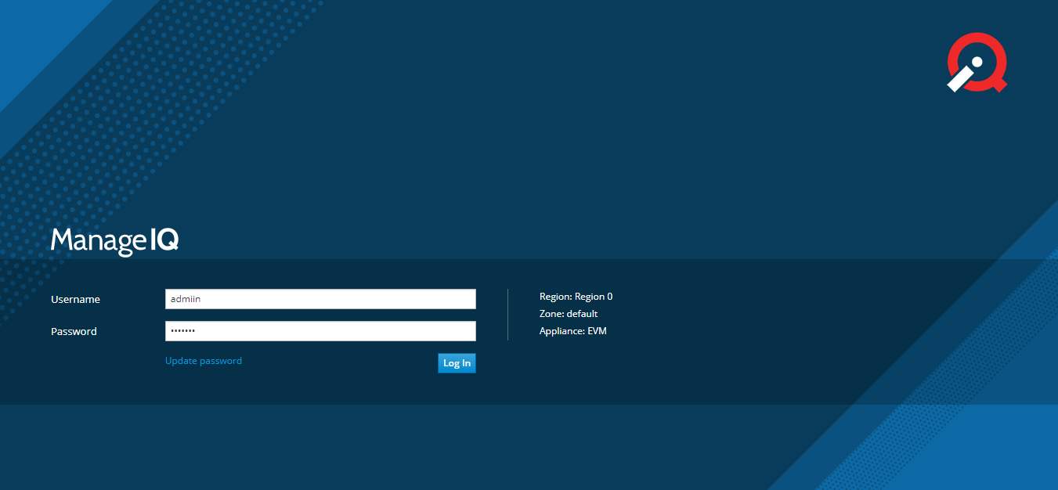

# Dashboard

After logging-in into the application you will see the Dashboard page displaying information related to Top CPU Consumer, Top Memory Consumers, Top Storage Consumers etc.

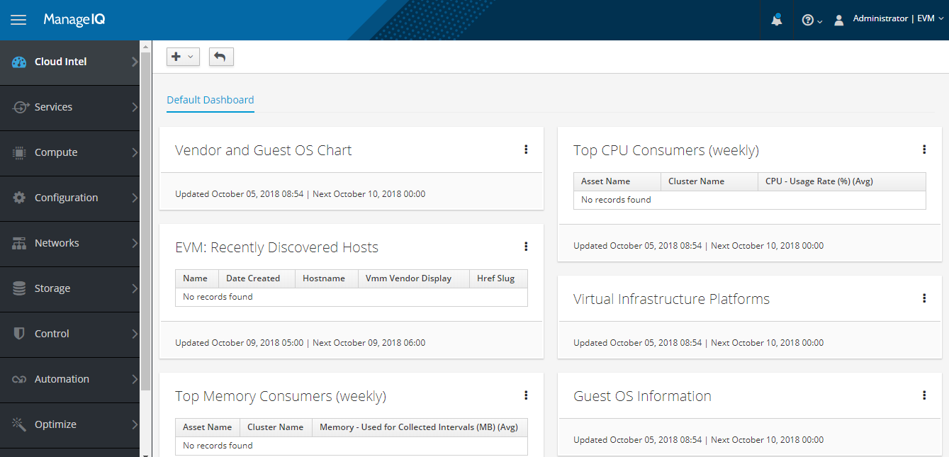

# Add a Cloud Provider

To continue with ManageIQ with any cloud, you need to add the cloud specific provider under Provider section. For adding provider of Telefonica cloud go to **Compute ->Clouds ->Providers** and under the **Configuration** drop down, click on **Add a new Cloud Provider** option.

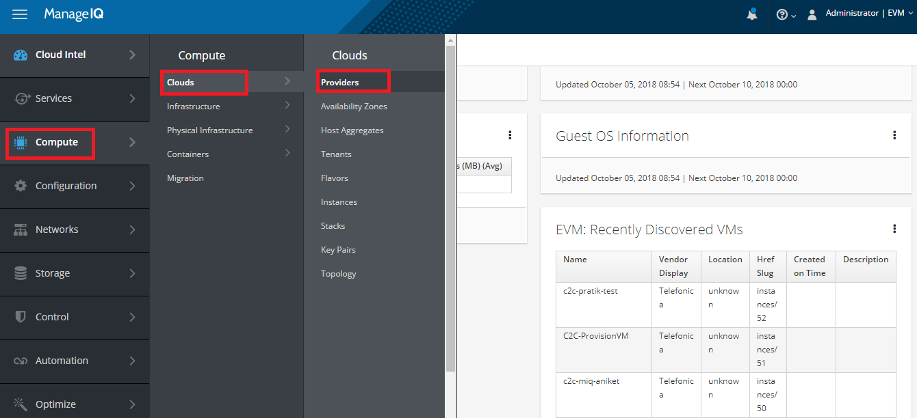

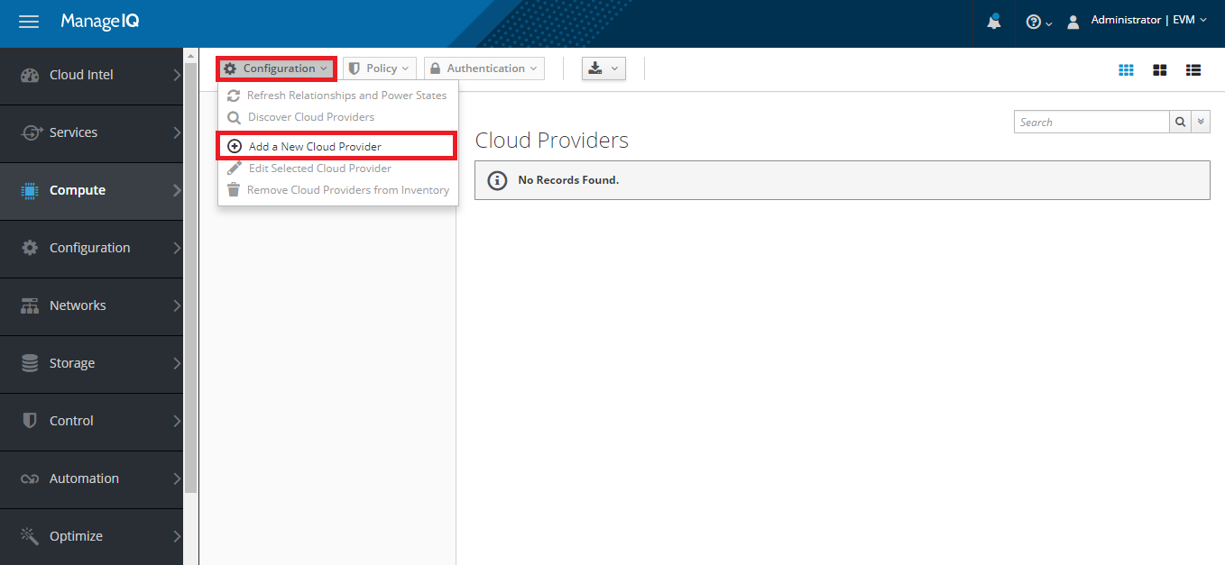

Here specify all the mandatory details required to add provider and click on **Validate** button to validate the credentials, once done with the successful validation, finally click on **Add** button to add the provider.

**Note: Please select the region as sa-brazil-1 as API response may vary.**

Please provide the following details while adding Telefonica provider into ManageIQ.

Name: *****

Type: Telefonica

API Version: Keystone v3

Region: Sa-brazil-1

Keystone V3 Domain ID: *****

Domain Name: Huawei China

Project Name: sa-brazil-1

Hostname (or IP v4 or v6 address): iam.sa-brazil-1.telefonicaopencloud.com

Username: *****

Password: *****

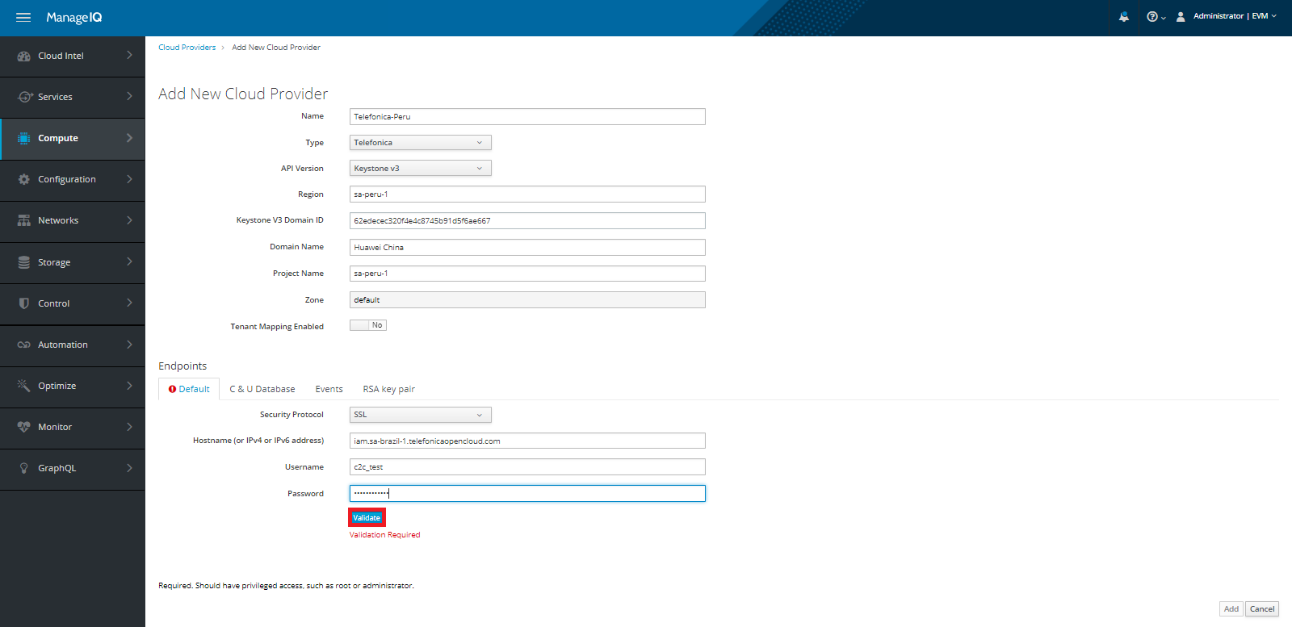

After adding the provider successfully, you can see the added provider displaying the count for number of available Instances and Images present under the region which was mentioned during provider creation. It takes some time to reflect the count of entities on the Dashboard page.

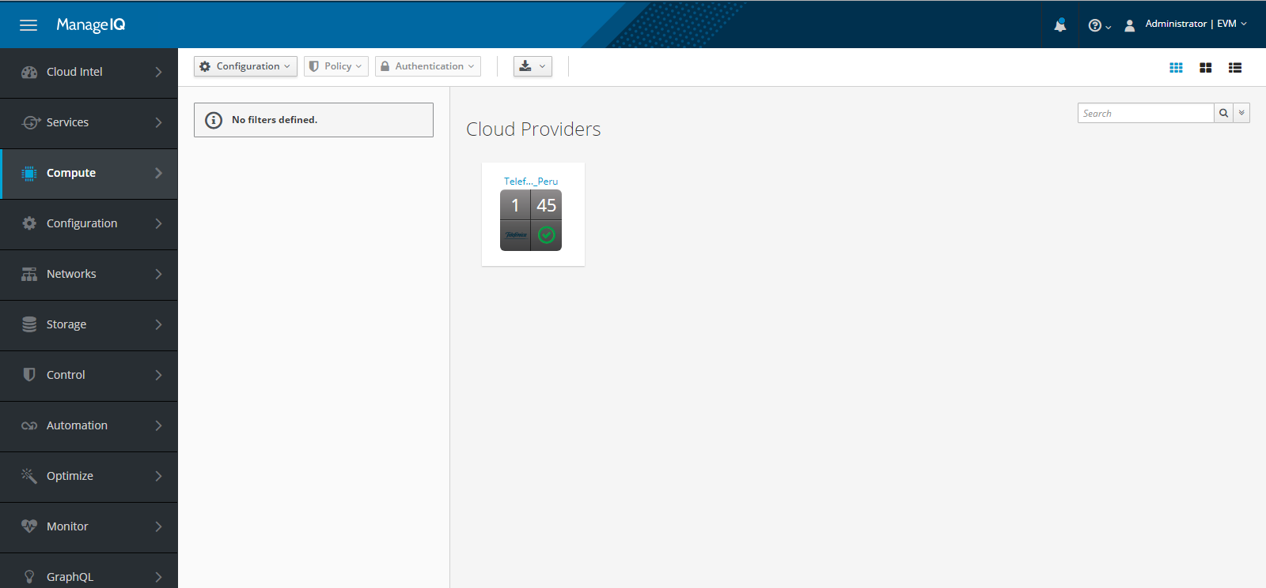

Moving inside the created provider you can see number of Flavors, Cloud Tenants, Images, Instances, Availability Zones, Security Groups, Cloud Networks and Cloud Volumes which you can drill down further.

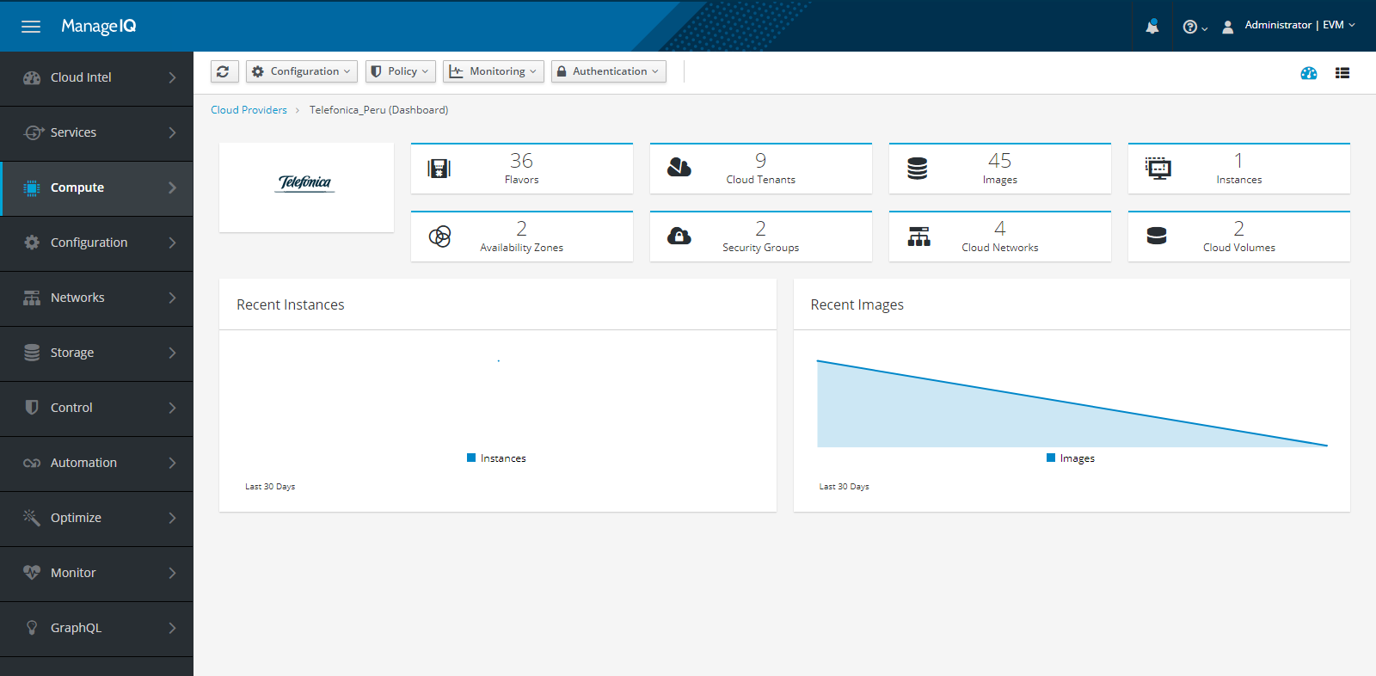

Clicking on the specific options you can switch to the respective Interface.

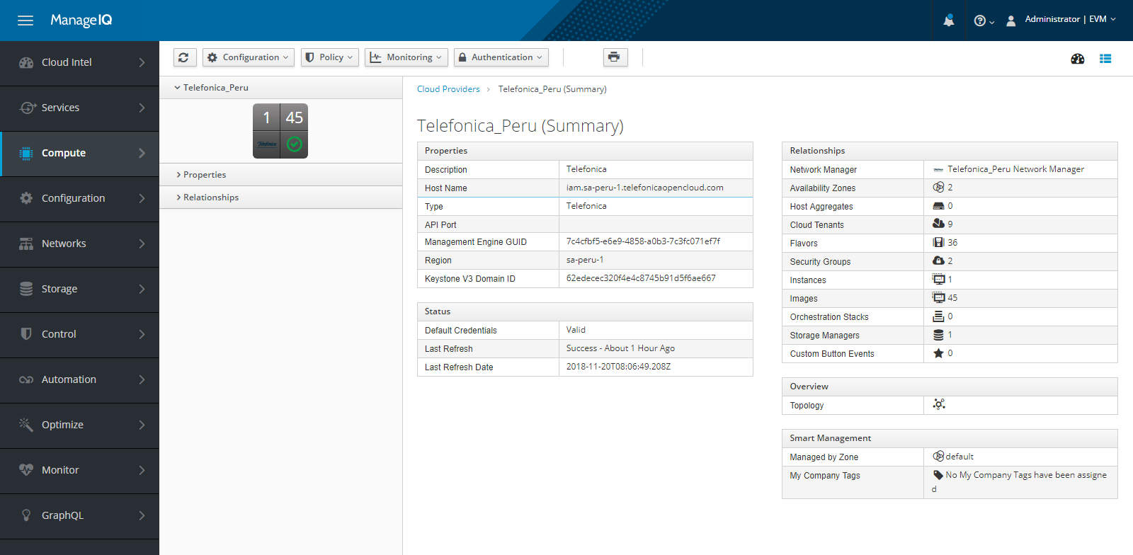

# Compute

## Availability Zones

To see the list of available zones, click on **Compute ->Clouds ->Availability Zones** option.

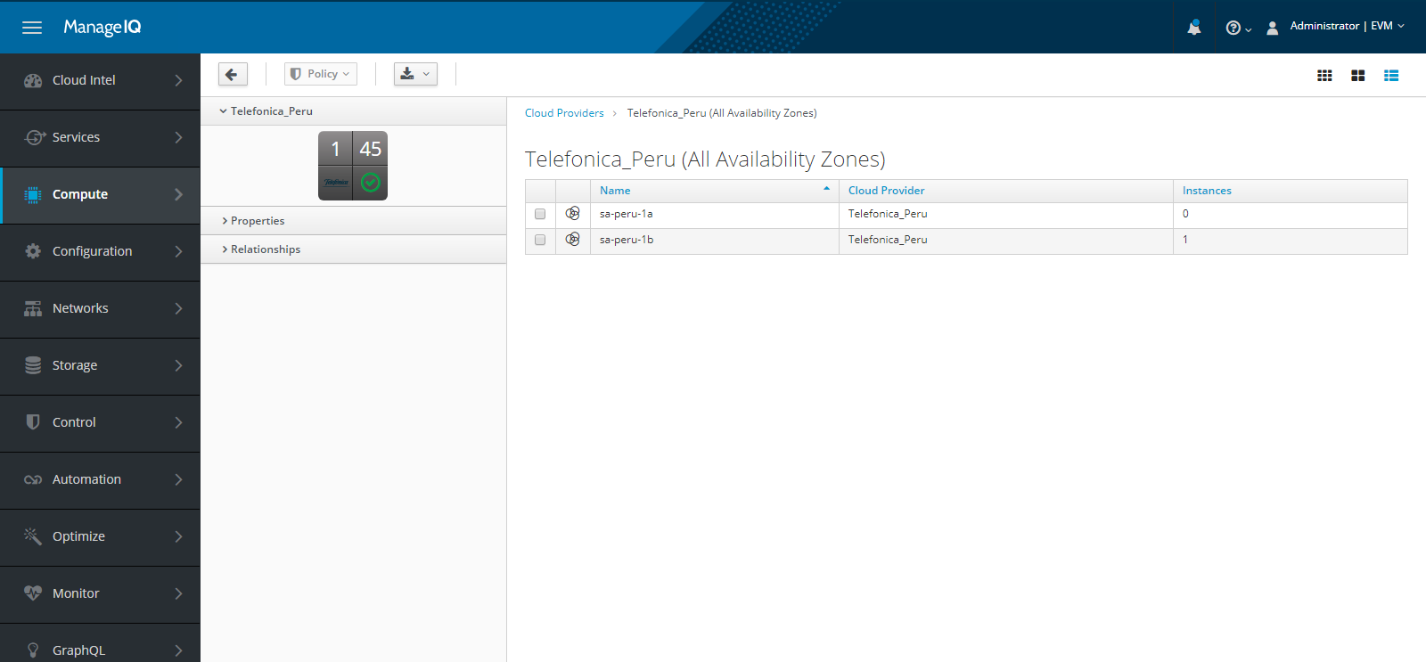

## Tenants

Go to **Compute ->Clouds ->Tenants**, here you can see the list of available tenants.

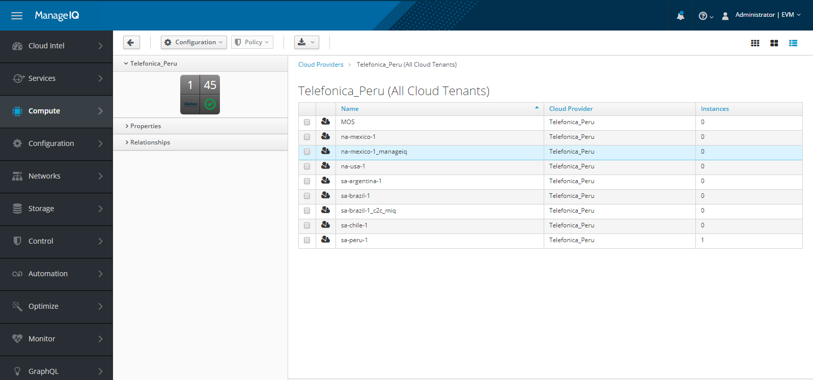

## Flavors

To see the list of available flavors, Go to **Compute ->Clouds ->Flavors.**

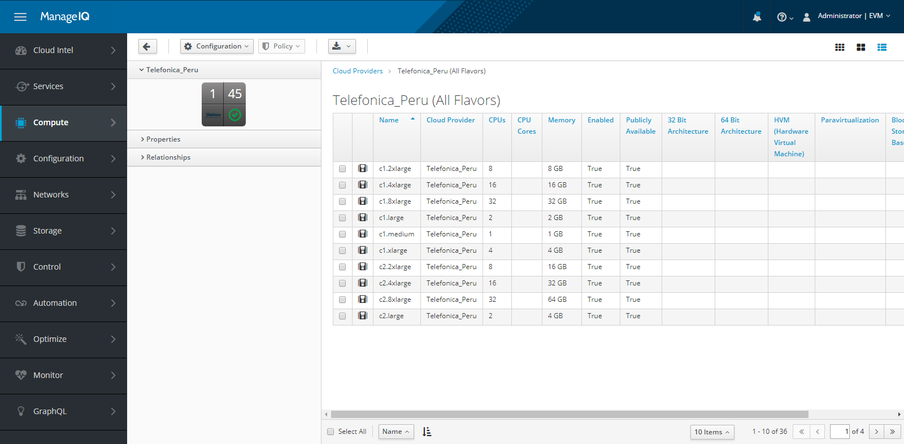

Moving inside the Flavor displays information related to CPUs, Memory, Status of Enabled, Public, Cloud subnet required.

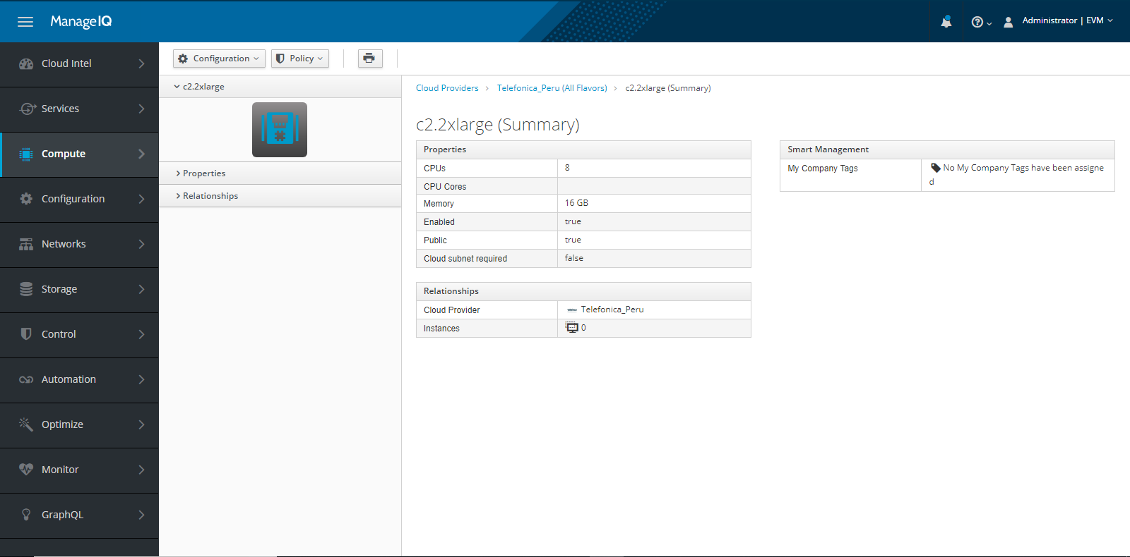

## Instances

To perform operations related to instance like Provision VM, Delete VM, Get VM information, Start a VM, Stop a VM, Restart a VM, Attach a disk onto a VM, Detach a disk from a VM, Get disks list of a VM, List the Image, List the security groups, Create/Delete a snapshot, List the flavors, Go to **Compute ->Clouds ->Instances** you will see the list of available instances.

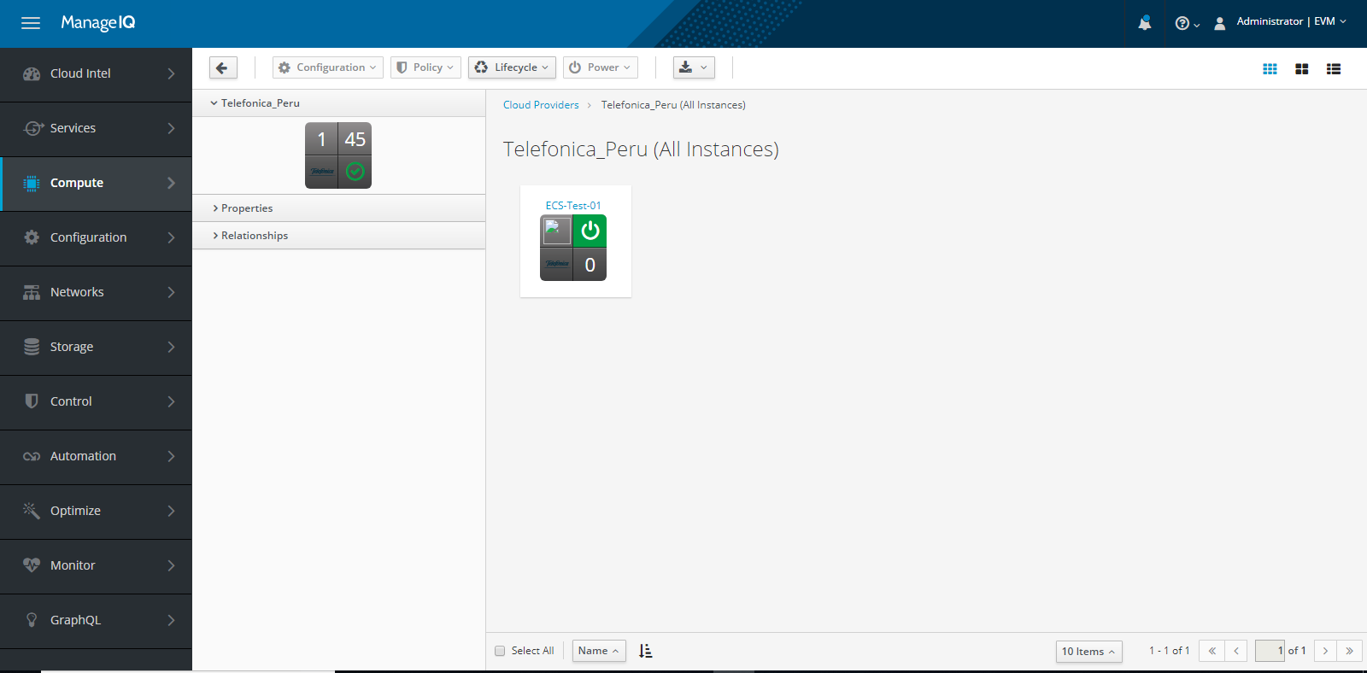

### Provision VM

To Provision a VM click on **Lifecycle** option and select **Provision Instance** option.

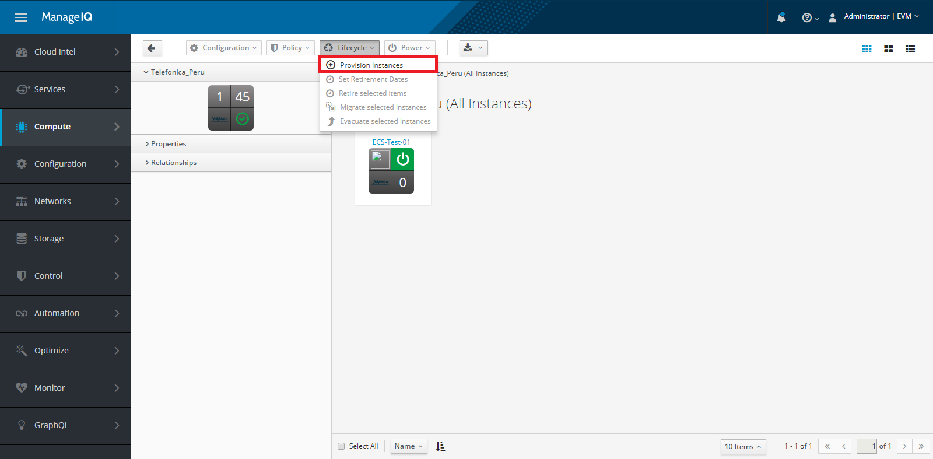

Choose the type of operating system for which you want to create a VM and click on **Continue** button.

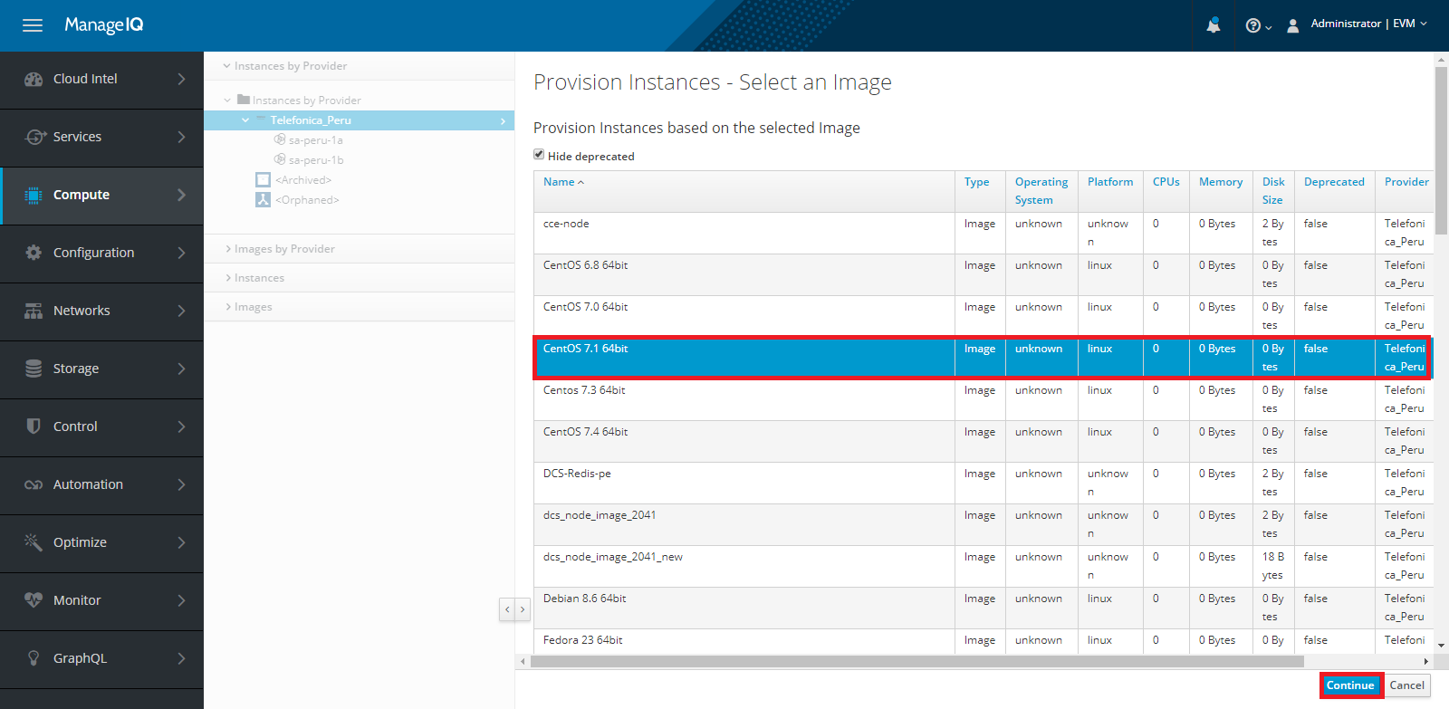

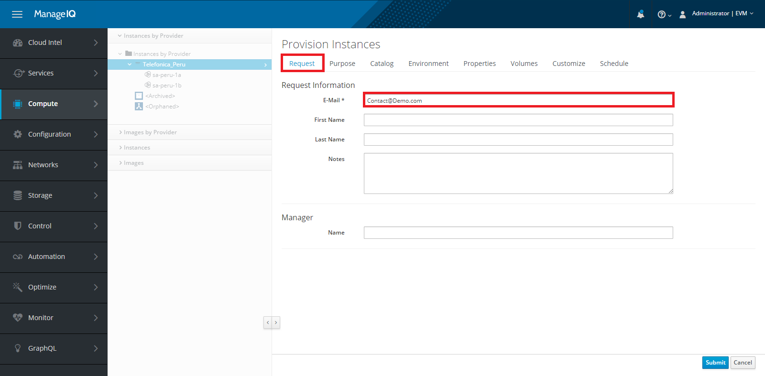

Enter all the mandatory details and switch to **Catalog** Tab, Enter the **Instance** **Name** for the instance.

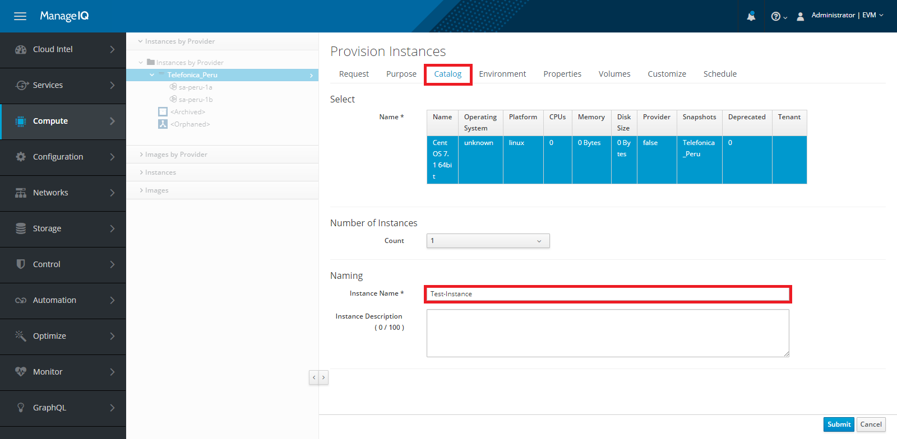

Now switch to **Environment** Tab, enter all the required details.

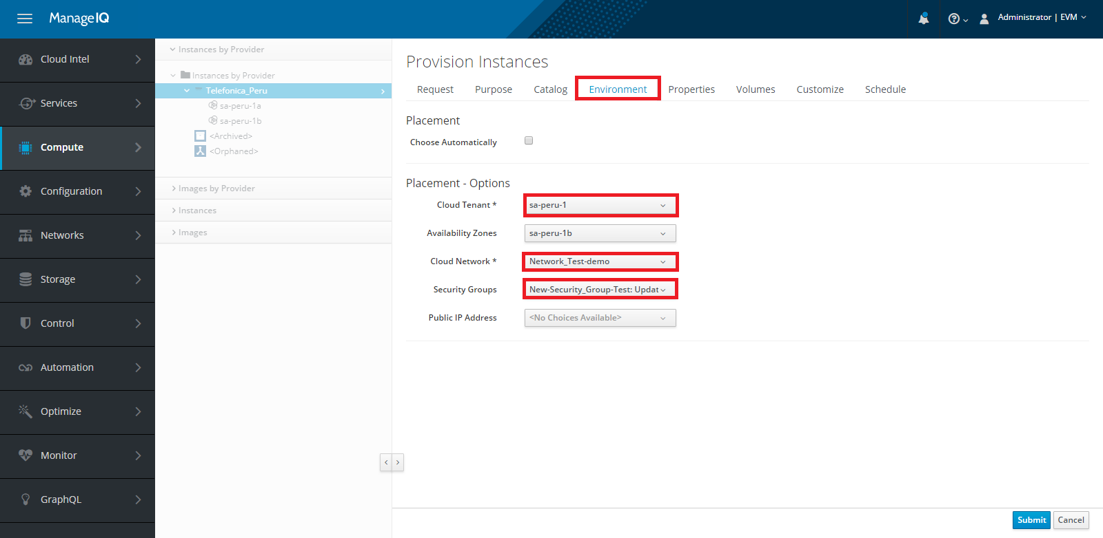

Go to **Properties** option, select **Instance Type** and **Access Key** and click on **Submit** button. You can specify details for other tabs also like Volumes, Customize, Schedule which are not mandatory field.

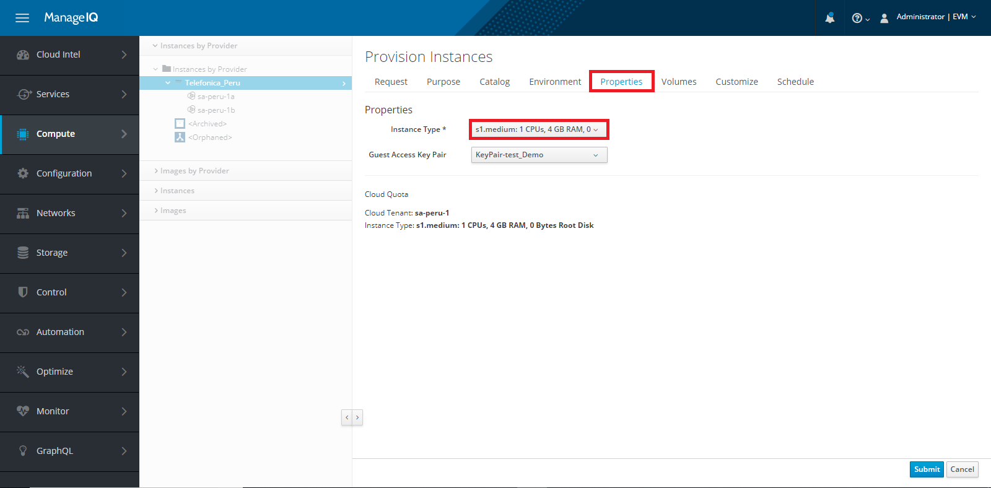

Once the value of **Request State** column comes in **Active** state means Instance has been created successfully. If any error occurs, you can check the error in **Last Message** column.

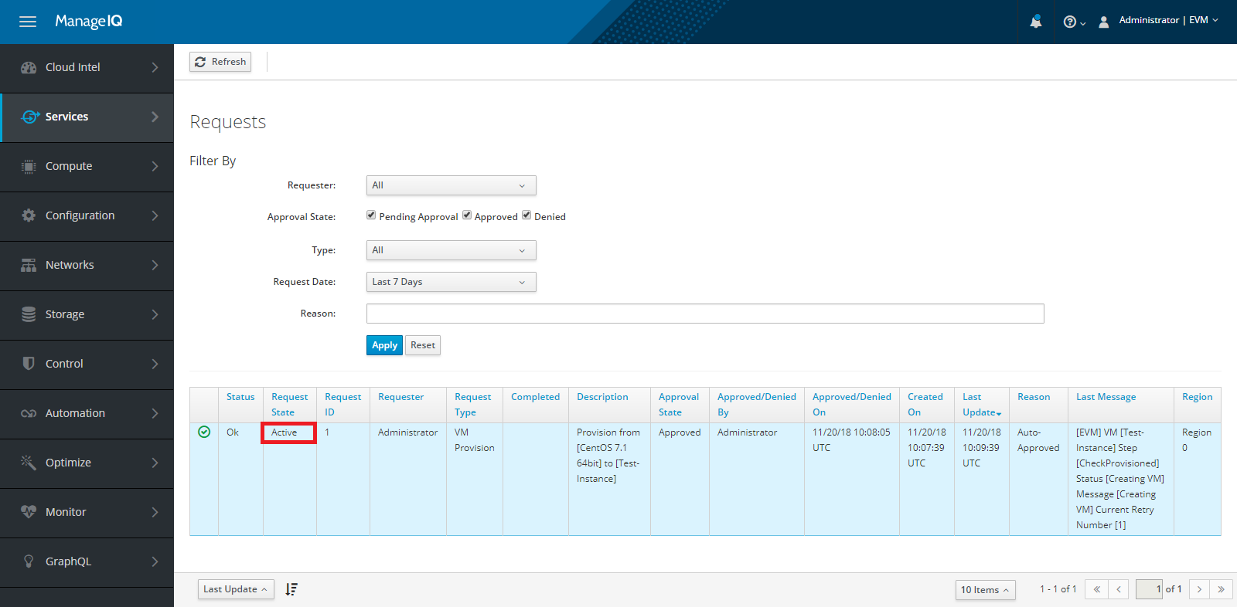

Select the created instance, click on **Power** option from top navigation. here you can Power On, Power Off and Restart the instance.

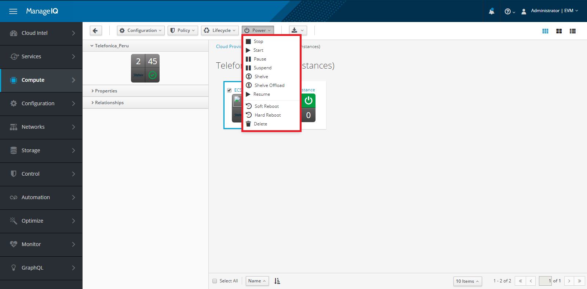

Explore the created instance by clicking on it.

Select the **Configuration** option and choose the required operation to perform on the selected instance.

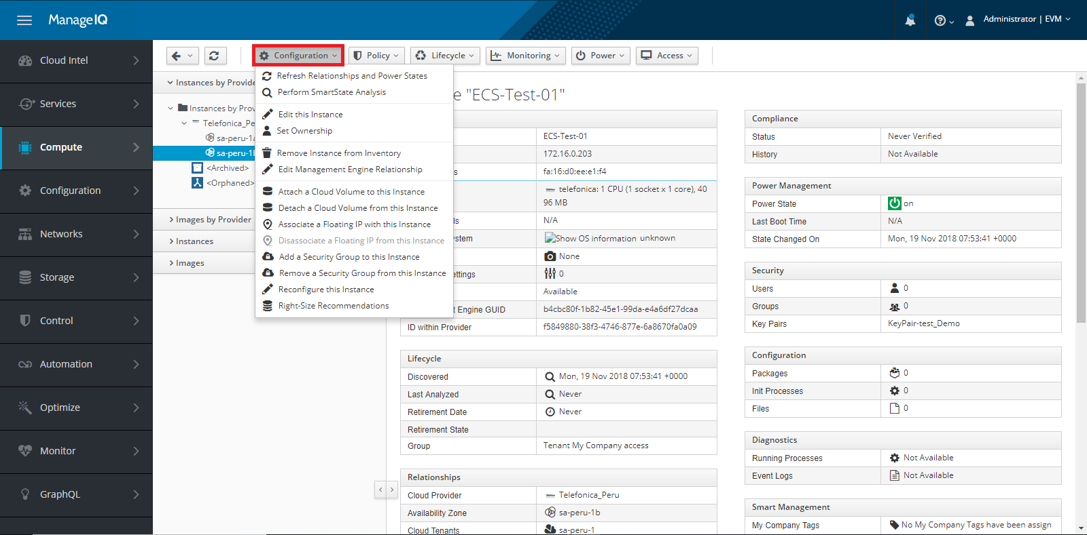

Here you can perform the operations like:

* Refresh Relationships and Power States
* Edit this Instance
* Remove Instance from Inventory
* Attach a Cloud volume to this Instance
* Detach a Cloud volume from this Instance
* Add a Security Group to this Instance
* Remove a Security Group from this Instance
* Reconfigure this Instance

## Topology

In topology section you can see the graphical view of all the VMs, Availability Zones, Tenants etc.

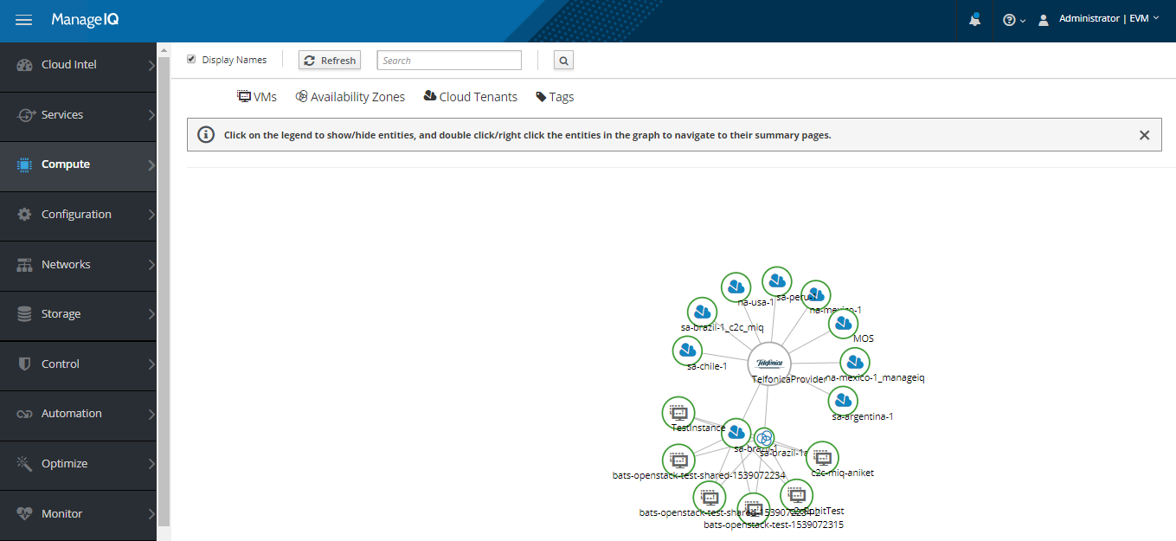

# Networks

## Networks

Go to **Networks ->Networks** tab. You can Create, Edit, Delete and see the list of available networks.

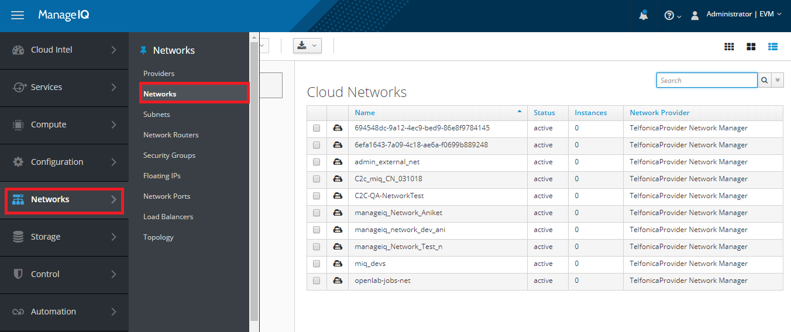

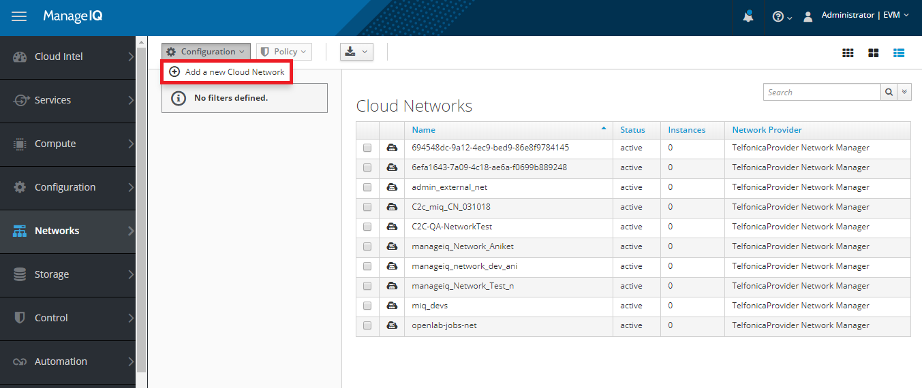

### Add network

Go to **Networks ->Networks ->Configuration ->Add a new Cloud Network** Tab. Specify the Name for network, Cloud Tenant, Network Type to add new cloud network.

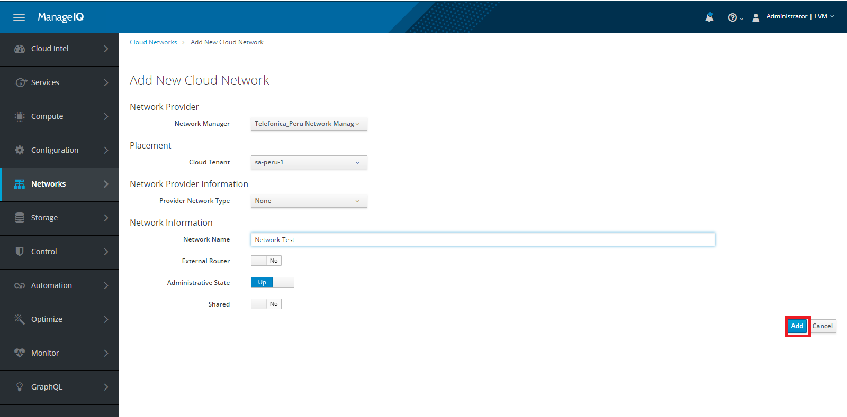

### Edit Network

Go to **Networks ->Networks,** you can edit cloud network. Select cloud network and go to Configuration and click on edit this Cloud Network.

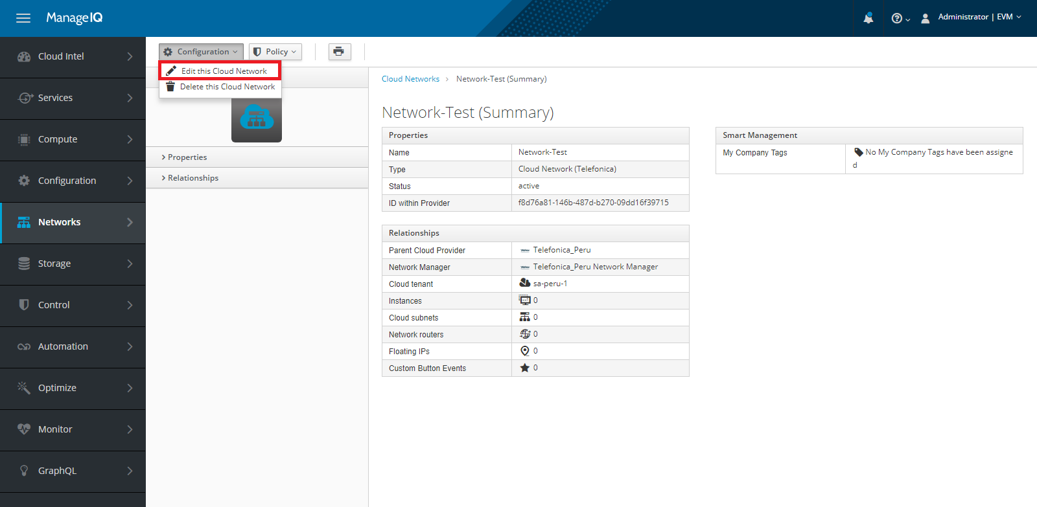

You can edit the name of Cloud Network, as shown in below image.

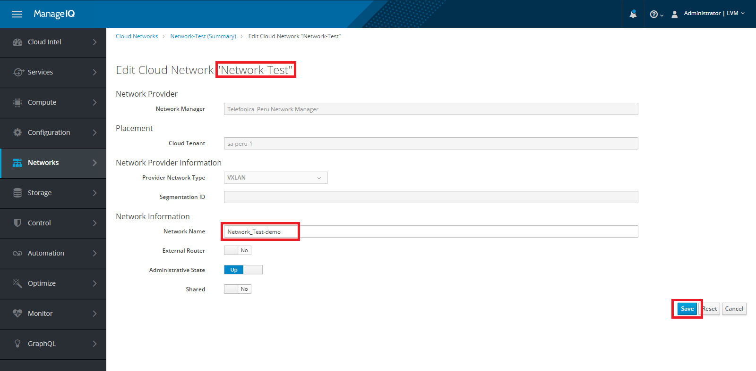

### Delete Cloud Subnet

Go to **Networks -> Subnet.** Go to the **Configuration** and click on **Delete this Cloud Subnet** option. As shown in below image.

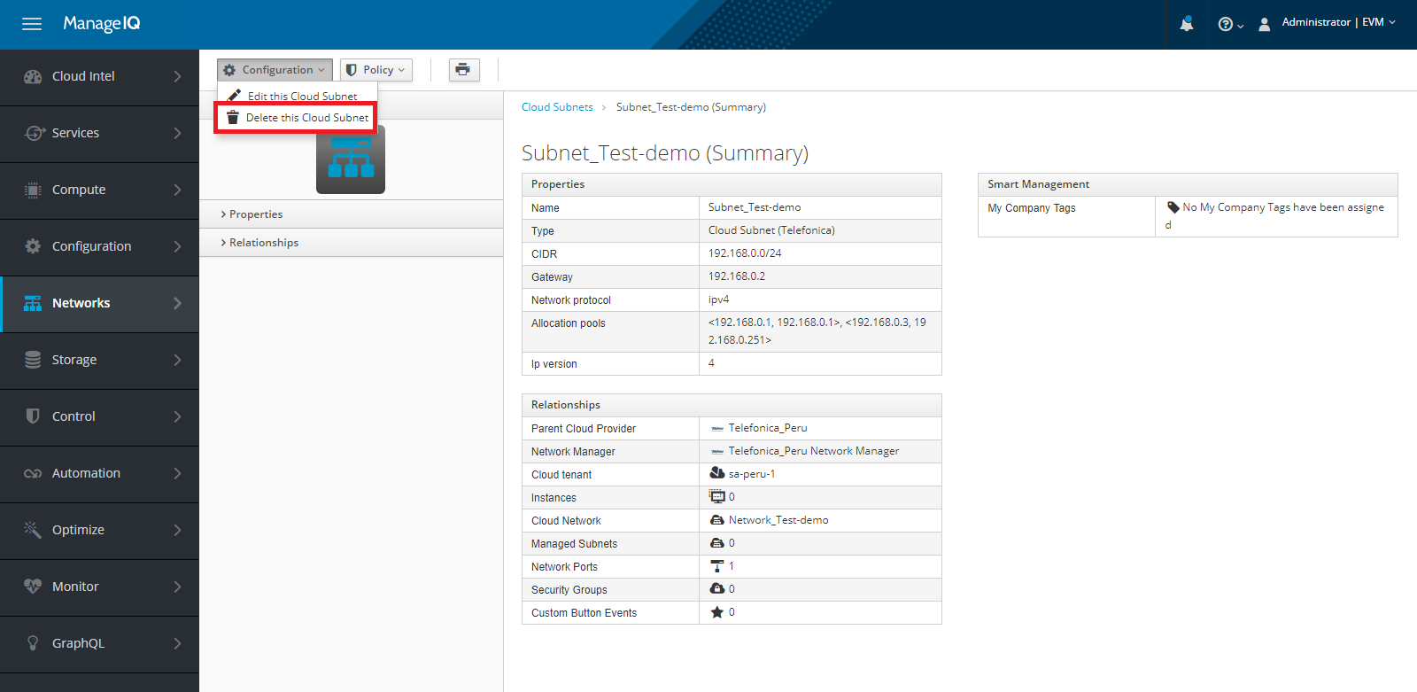

## Subnet

You can Create, Delete, Edit and See the list of available Subnets under **Networks ->Subnets** tab.

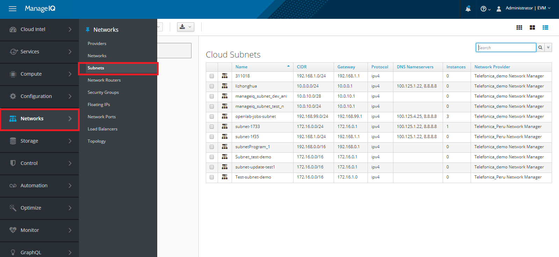

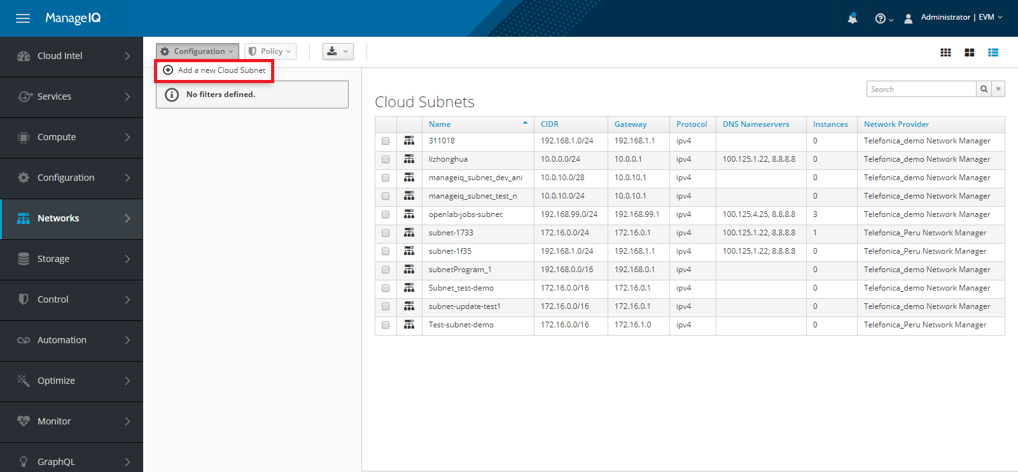

### Add a Cloud Subnet

Go to **Networks ->Subnet ->Configuration ->Add a new Cloud Subnet** tab. To add cloud subnet, select **Network Manager**, select **Cloud Tenant** **Placement**, after that in Cloud Subnet Details select Network, give a valid Subnet name, Gateway and Subnet CIDR as shown in below image.

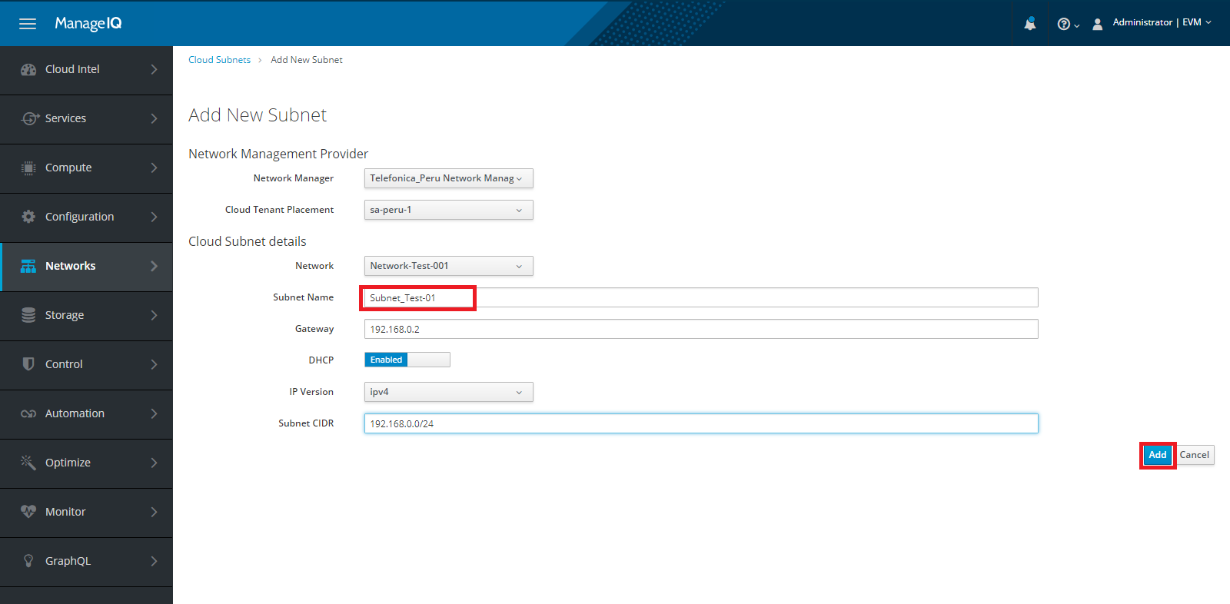

### Edit Cloud Subnet

Go to **Networks ->Subnet,** here you can also edit a Cloud Subnet. Go to the Configuration and click on edit this Cloud Subnet option. As shown in below image.

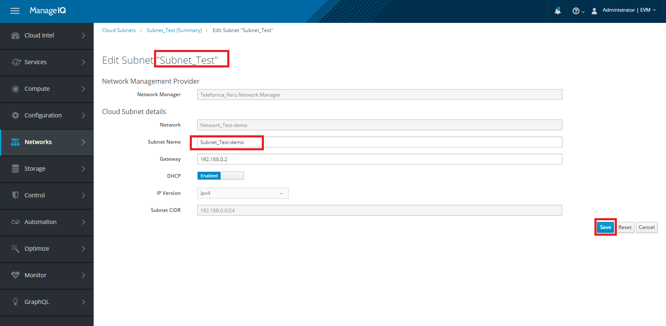

You can Edit Subnet Name and Gateway as shown in below image.



### Delete Cloud Subnet

Go to **Networks ->Subnet,** here you can also delete a Cloud Subnet. Go to the **Configuration** and click on **Delete this Cloud Subnet** option. As shown in below image.



## Network Routers

To create VPC on Telefonica cloud, Go to **Networks ->Network Routers.** You can Add a new Router, Edit the Router, Delete the Router and see the list of available Routers.

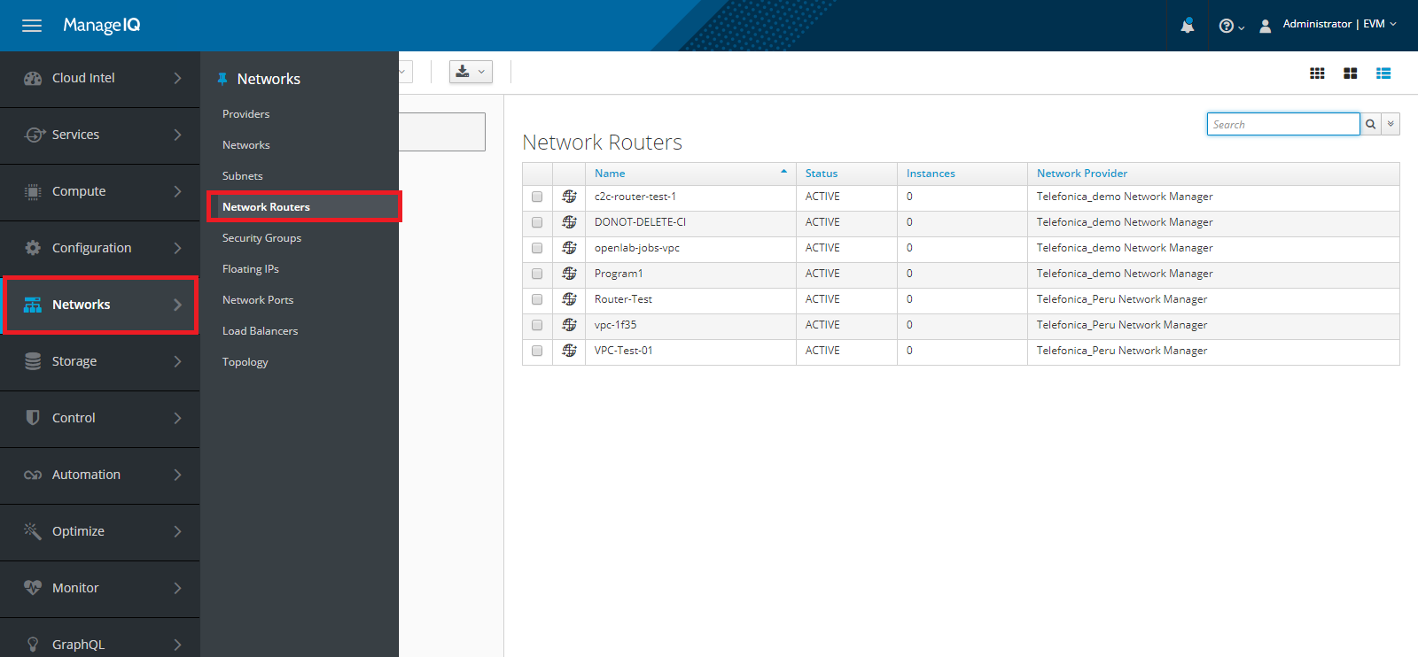

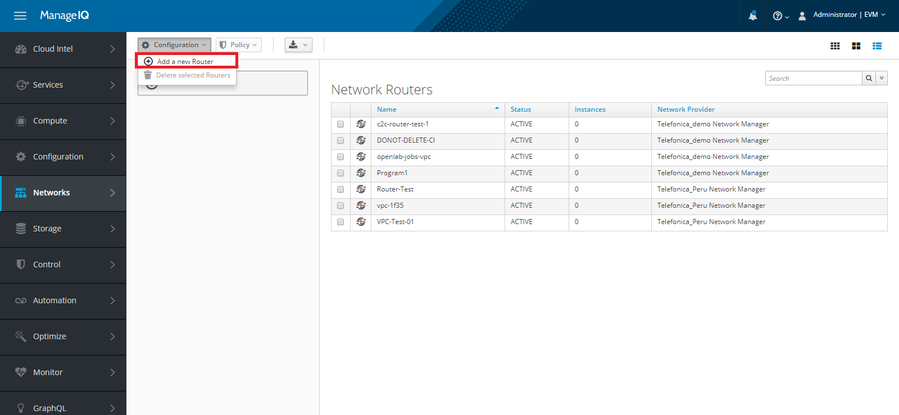

### Add a new Router

Go to **Networks ->Network Routers ->Configuration ->Add a new Router.** You can Add a new Router, as shown in below image.

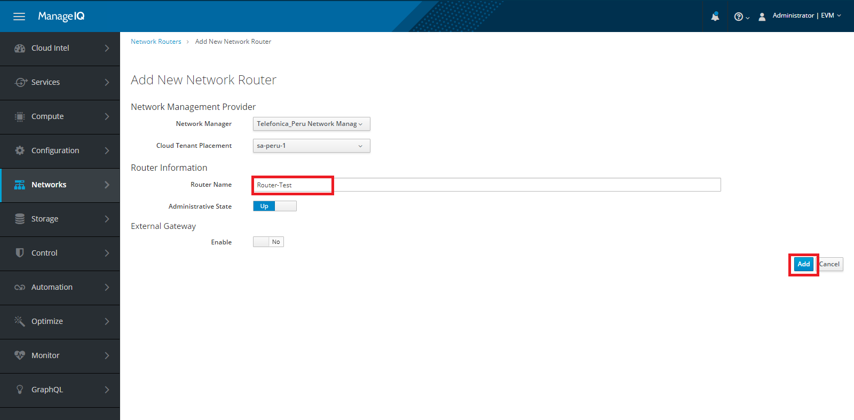

### Edit Network Router

Go to **Networks ->Network Routers,** select the specific router, click on **Configuration->Edit this Router** option. As shown in below image.

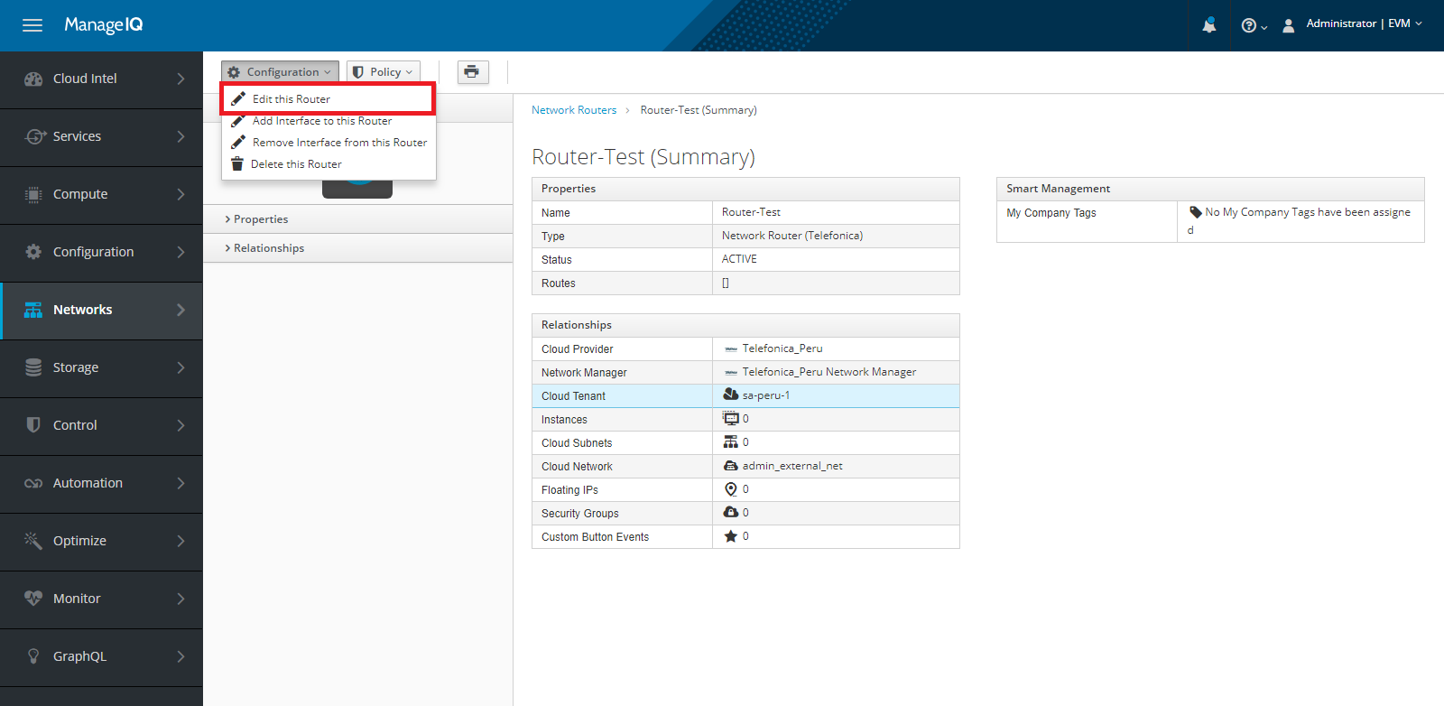

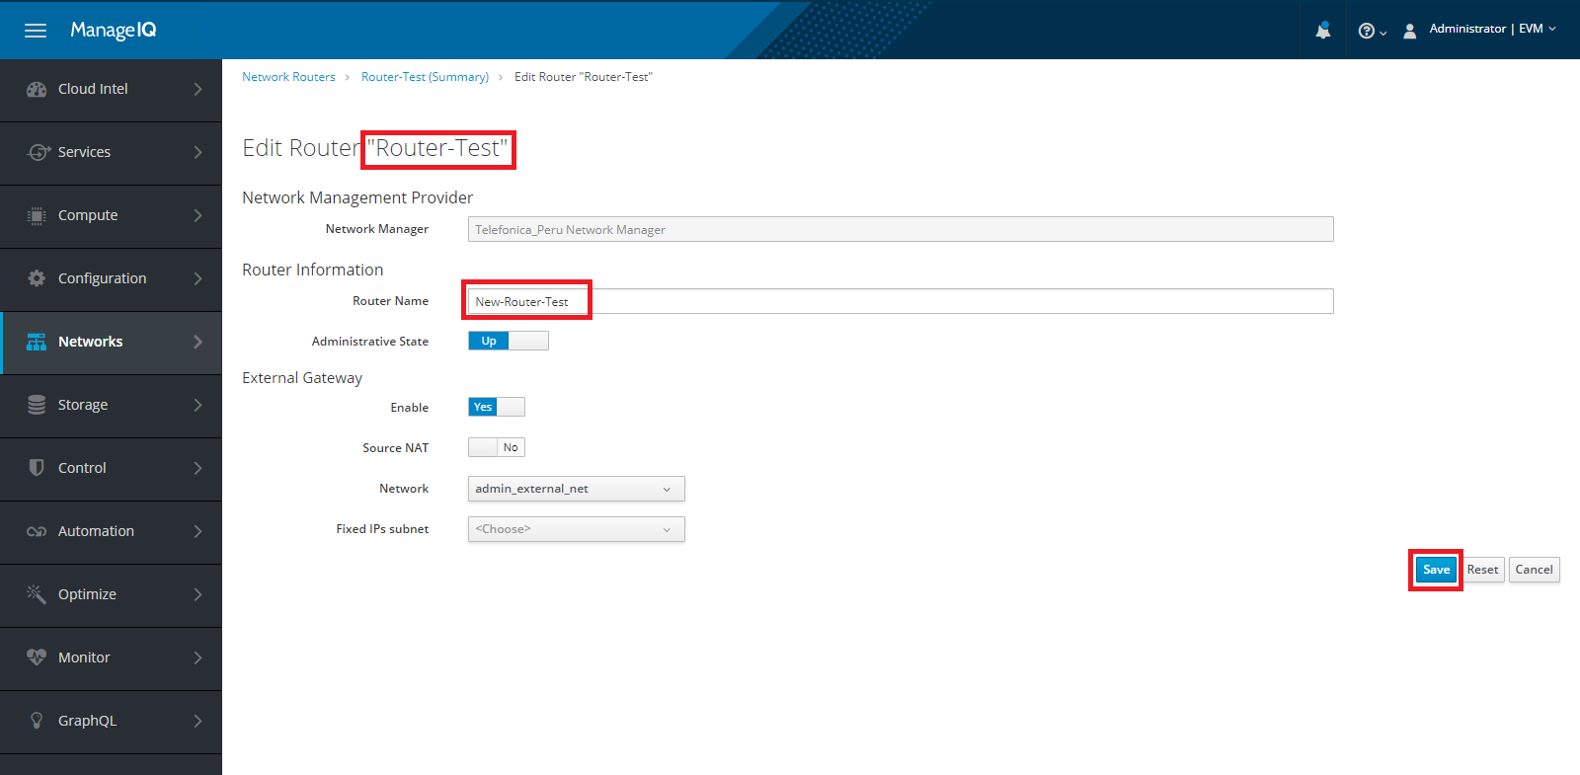

### Add interface to Router

Go to **Networks ->Network Routers,** select the specific router, after that click on **Configuration->Add Interface to this Router** option. As shown in below image.

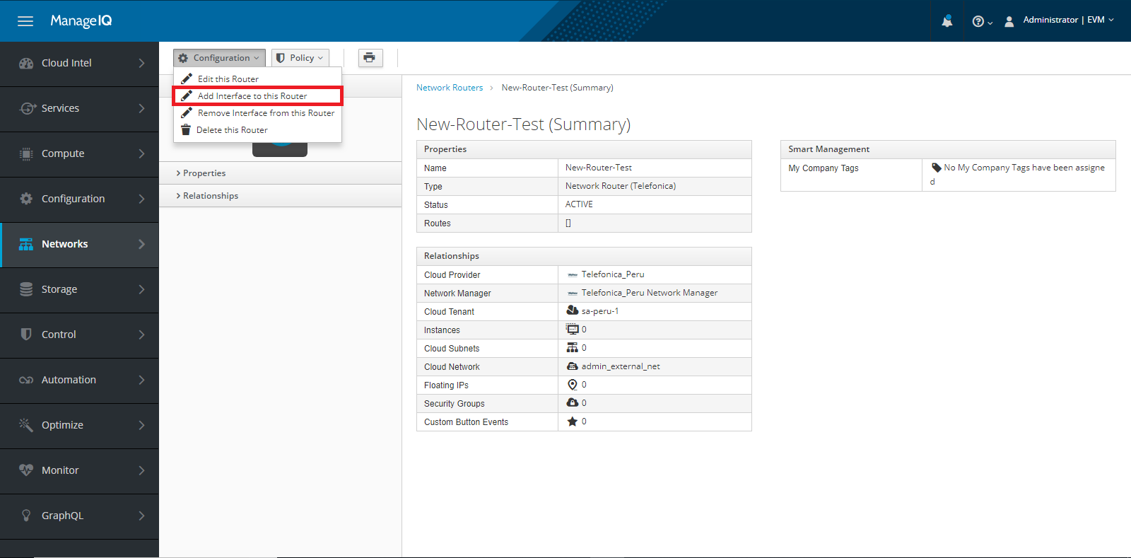

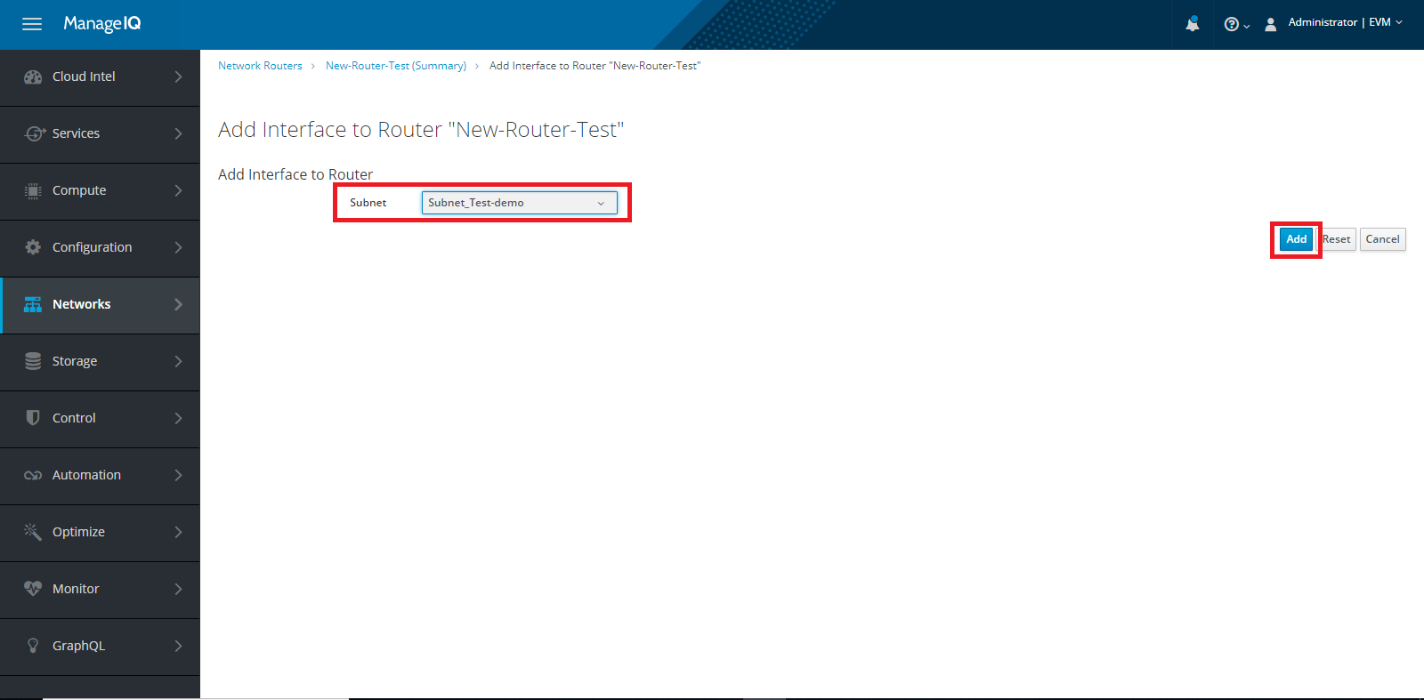

### Remove interface from Router

Go to **Networks ->Network Routers,** select the specific router, after that click on **Configuration**->**Remove Interface from this Router** option. As shown in below image.

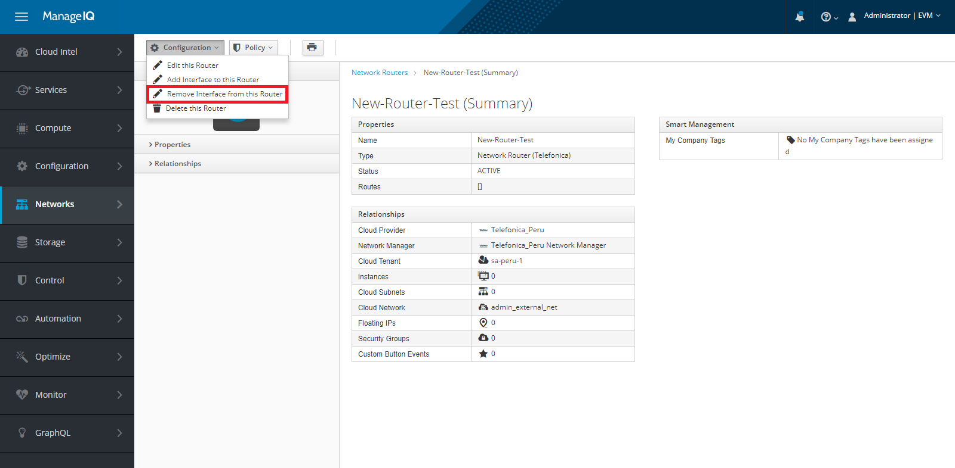

### Delete Router

To delete the router, Go to **Networks ->Network Routers ->Configuration -> Delete this Router.** You can delete Router, as shown in below image.

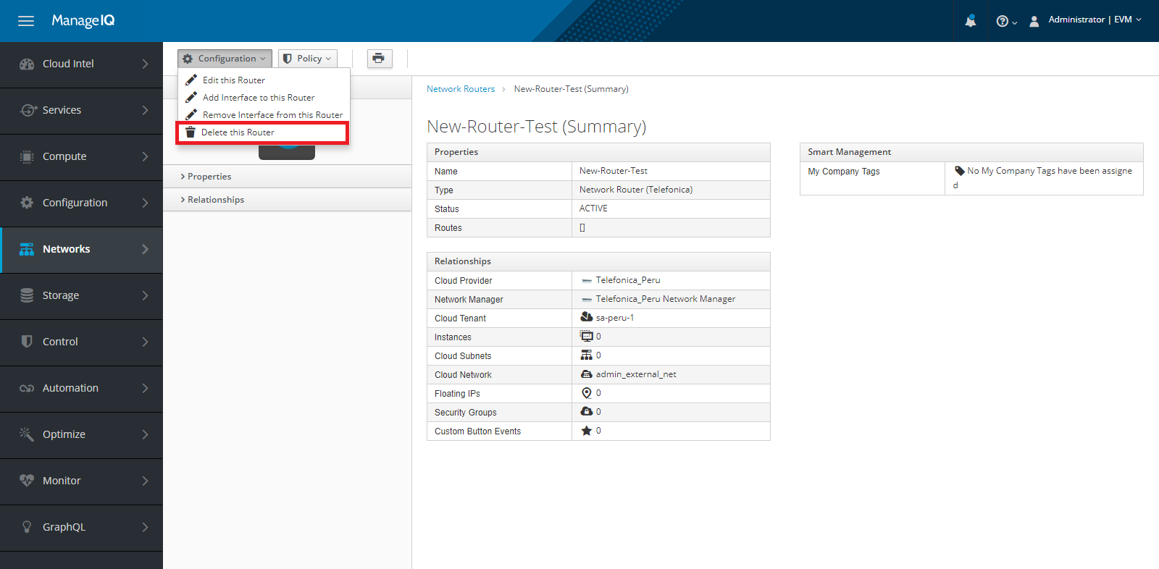

## Security Groups

Go to **Networks ->Security Groups**, here you can Add a new Security Group, Edit the Security Group, Delete the Security Group and see the list of available Security Group.

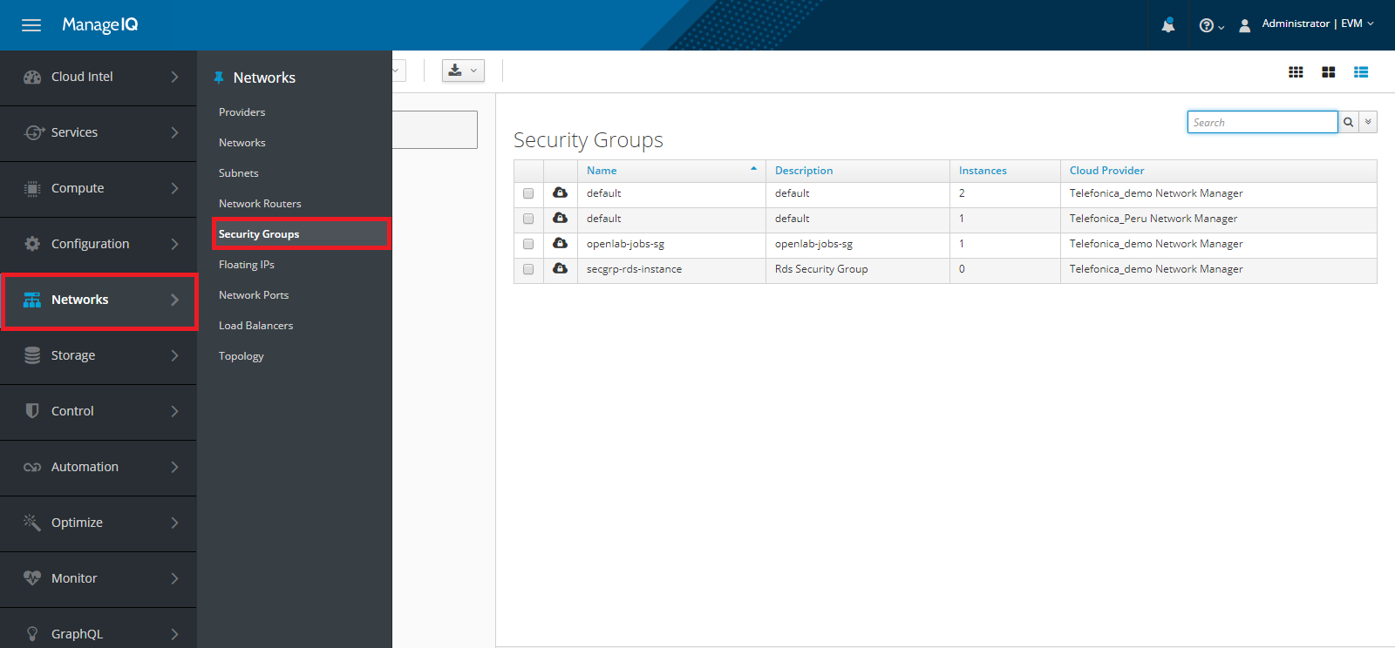

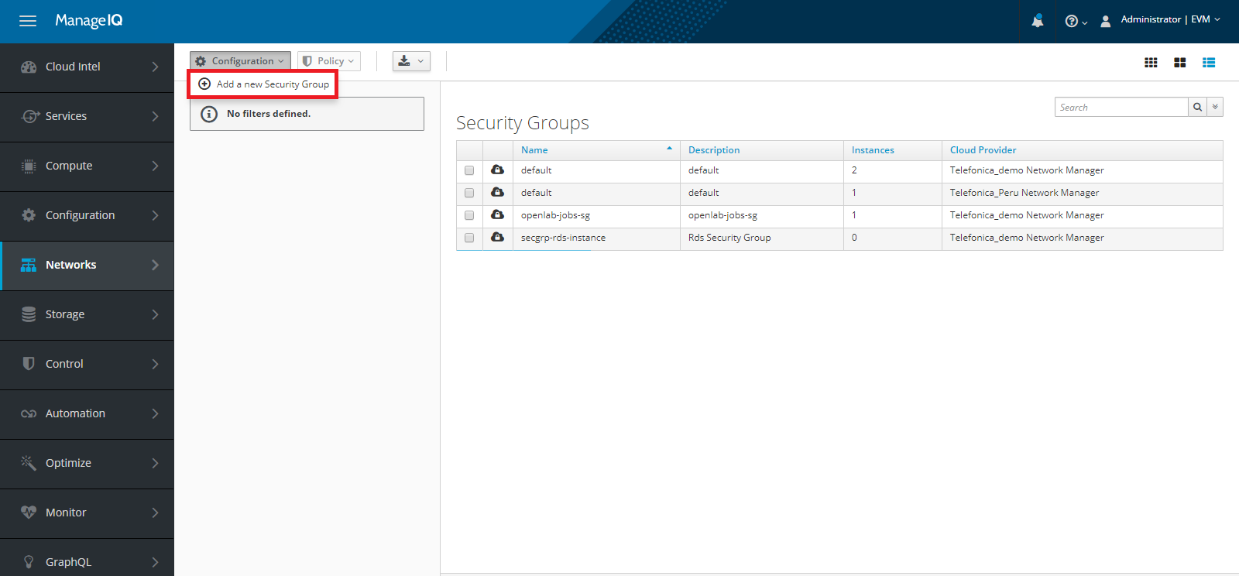

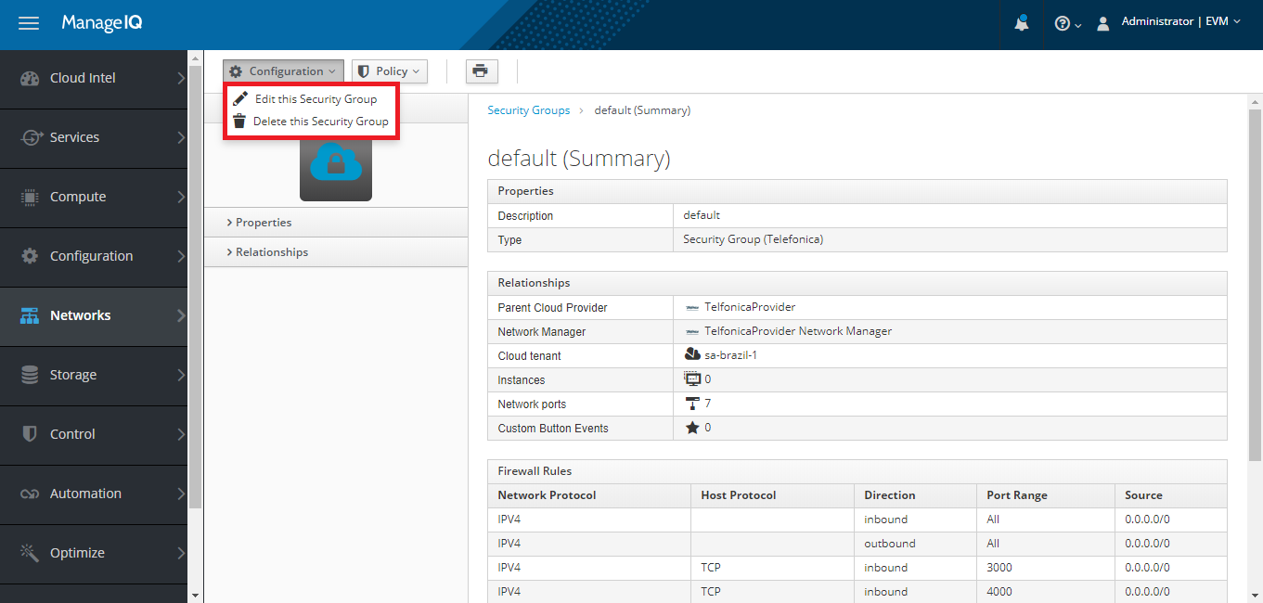

### Add Security Groups

To add a Security Group, Go to **Networks ->Security Groups**, click on **Configuration->Add a New Security Group** option. Select a Network Provider, give a valid Security Group Name, write Security Group Description, select the Cloud Tenant and click on **Add** button.

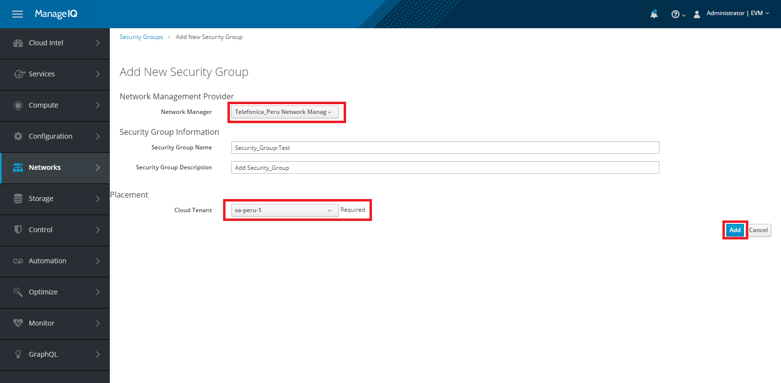

### Edit Security Group

To Edit Security Group, Go to **Networks ->Security Groups**, click on the respective Security Group from the list and then click on **Configuration**, select Edit this **Security** **Group** option. Here you can edit the Security Group Name, Security Group Description and Add Firewall Rules also.

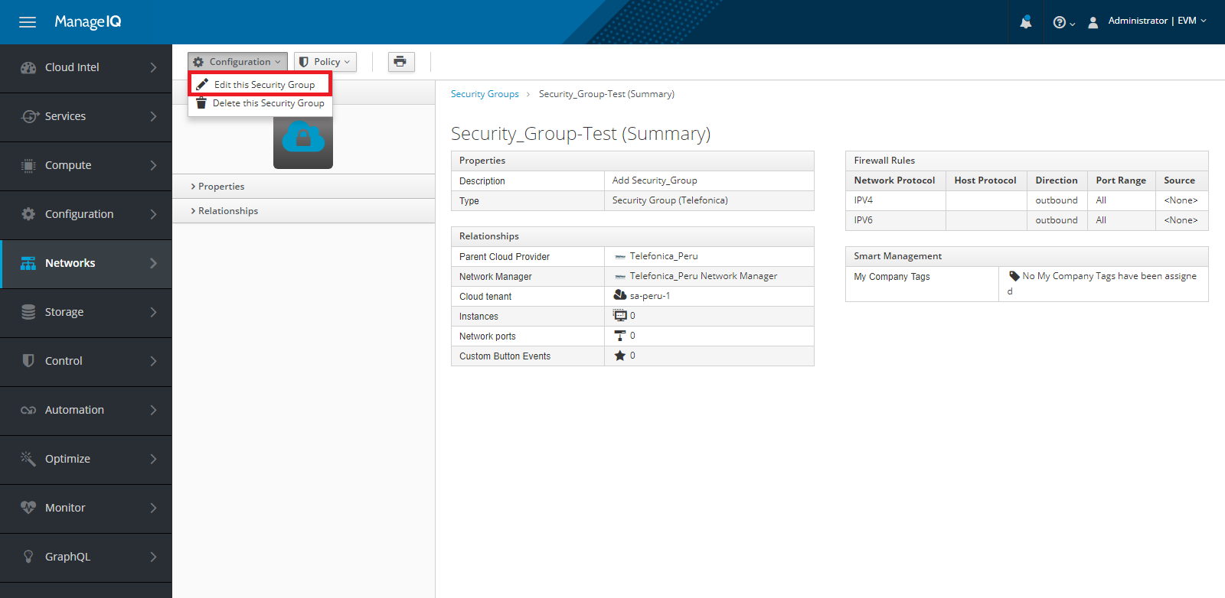

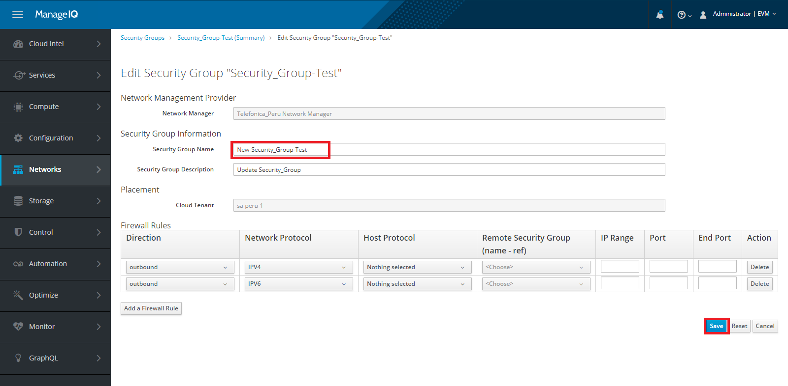

### Delete Subnet Group

To delete the Security Group, Go to **Networks ->Security Groups**, click on the specific security group from the list and then click on **Configuration->Delete this Security Group** option.

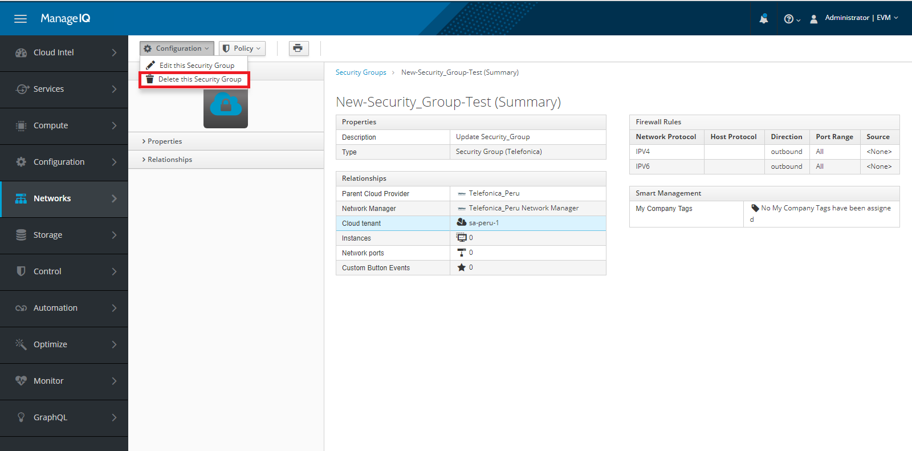

## Floating IP

Go to **Networks ->Floating IP**, here you can Add a new Floating IP, Delete the Floating IP and see the list of available Floating IPs.

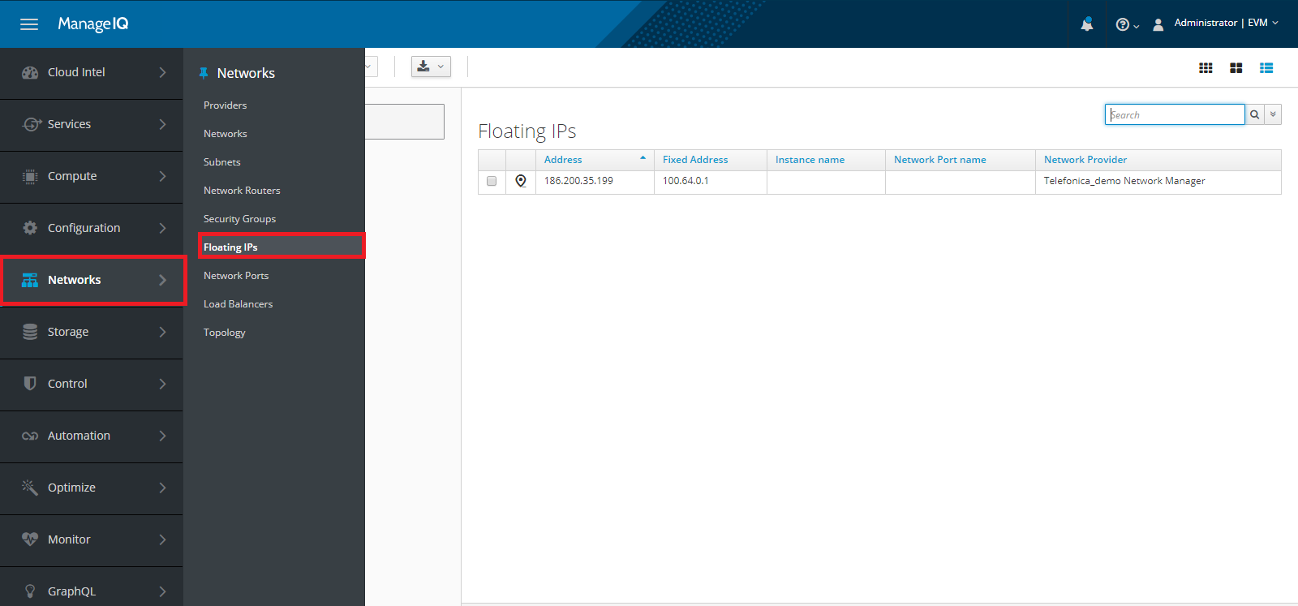

### Add Floating IP

To Add Floating IP, Go to **Networks ->Floating IP**. Click on **Add a new Floating IP** option, choose Network Provider, choose External Network, choose Cloud Tenant Placement and click on **Add** button.

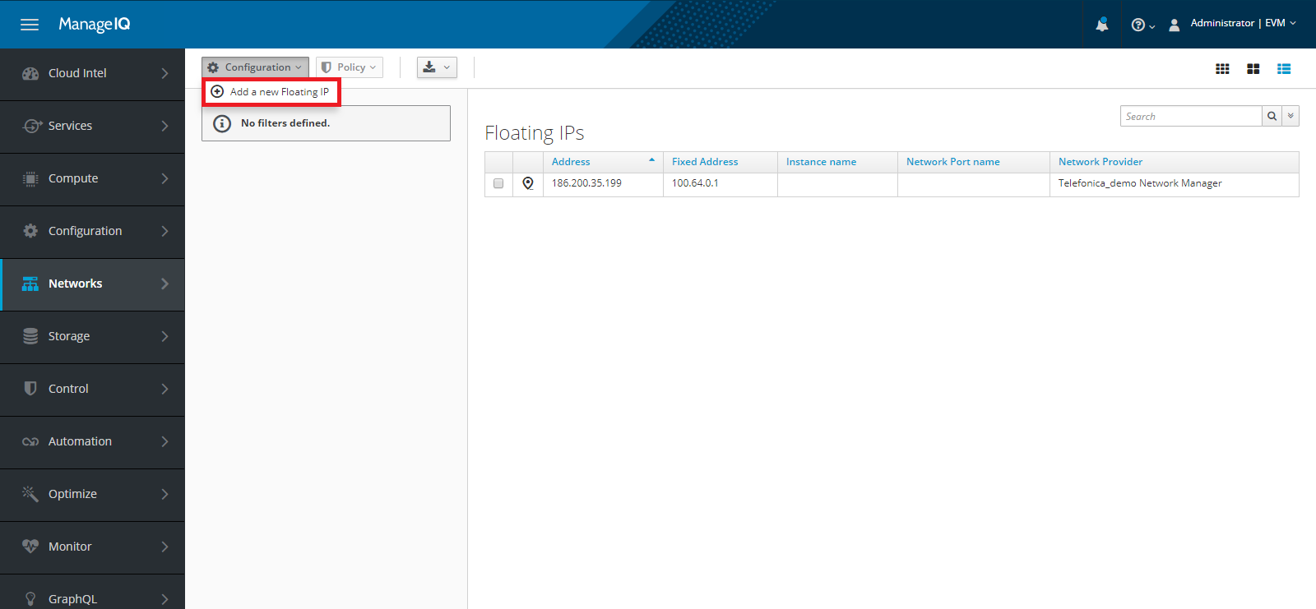

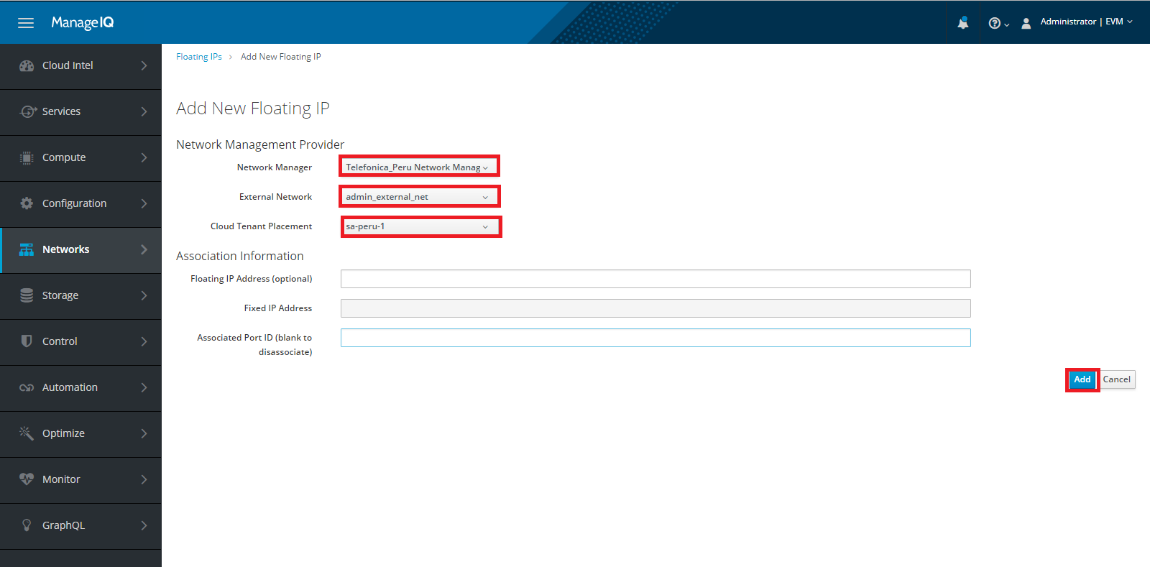

### Delete Floating IP

To Delete Floating IP, Go to **Networks ->Floating IP**. Go to the **Configuration** and click on **Delete this Floating IP** option. As shown in below image.

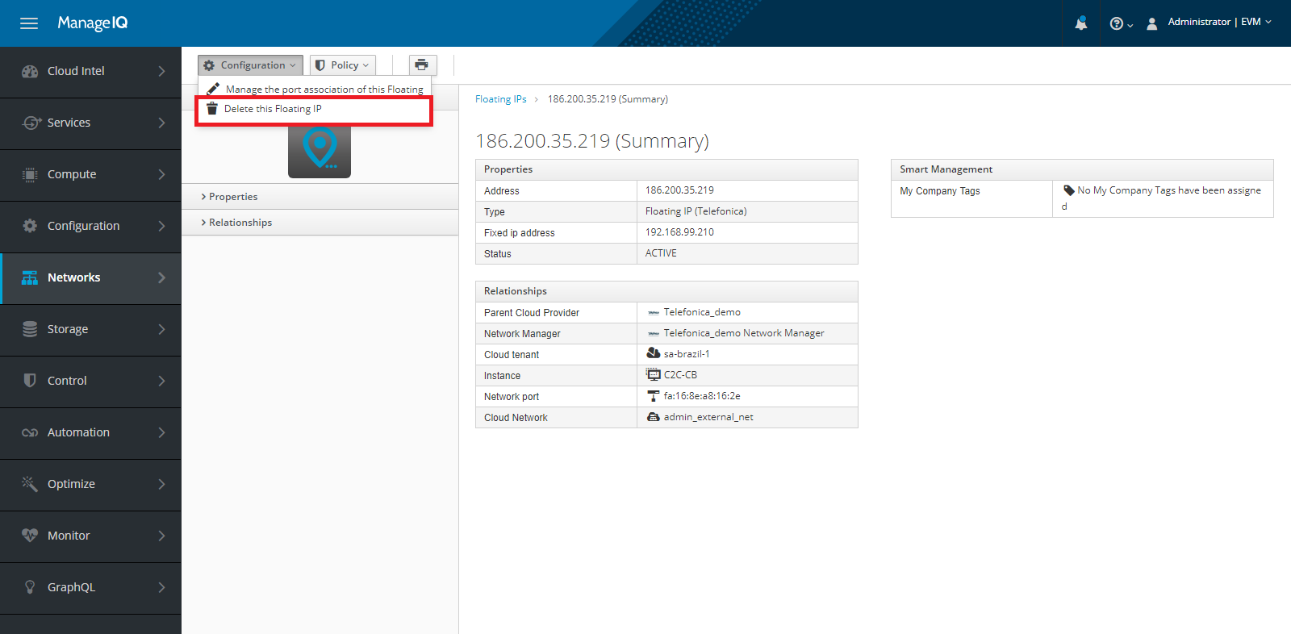

## Topology

Go to **Networks ->Topology**, here you can see the graphical representation of resources like

Availability Zones, Cloud Subnets, VMs, Security Groups, Floating IPs, Cloud Networks, Network Routers, Cloud Tenants, Tags, Load Balancer.

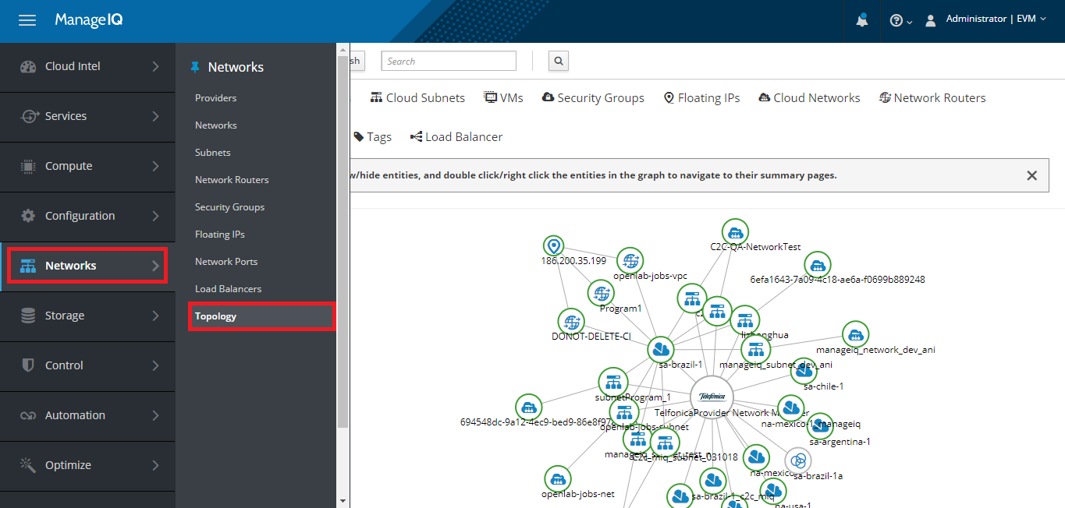

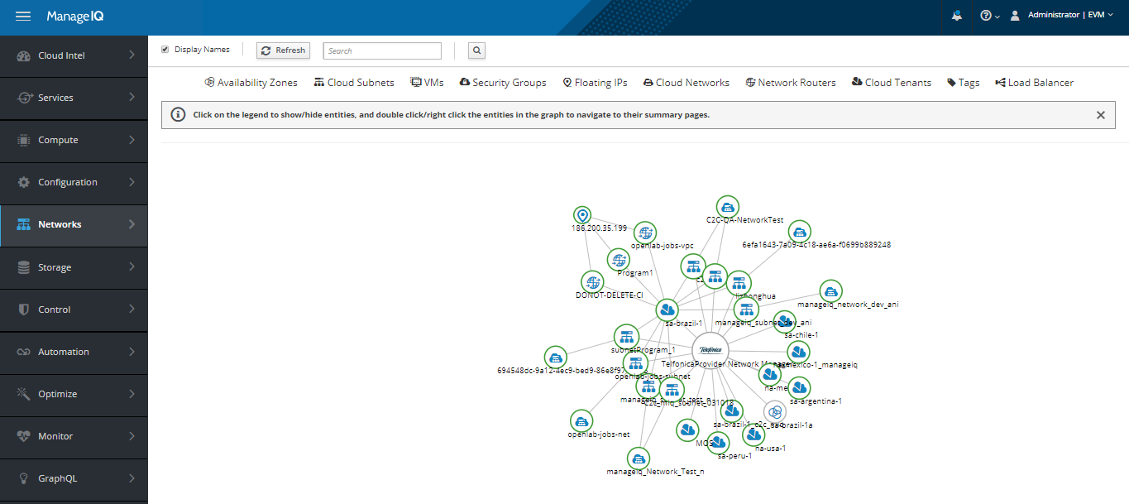

# Storage

## Volumes

Go to **Storage ->Block Storage ->Volumes**, here you can perform the operations like Add a new Cloud Volume, Edit the Cloud Volume, Delete the Cloud Volume, Attach Cloud Volume to an Instance, Detach Cloud Volume from an Instance, Create a Snapshot, Delete the Snapshot, List all disks, List the Snapshots, Get the Snapshot Information.

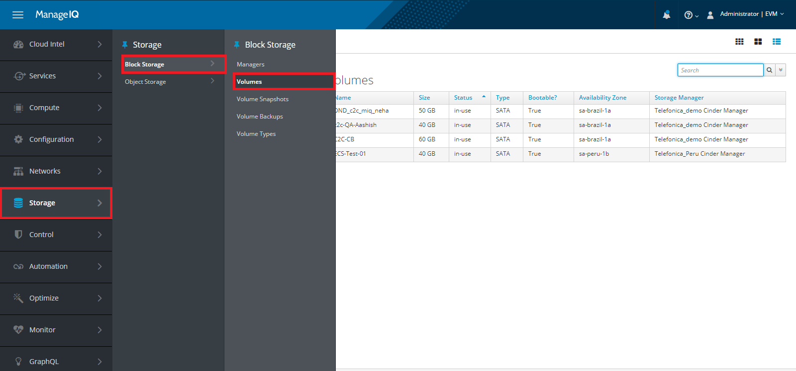

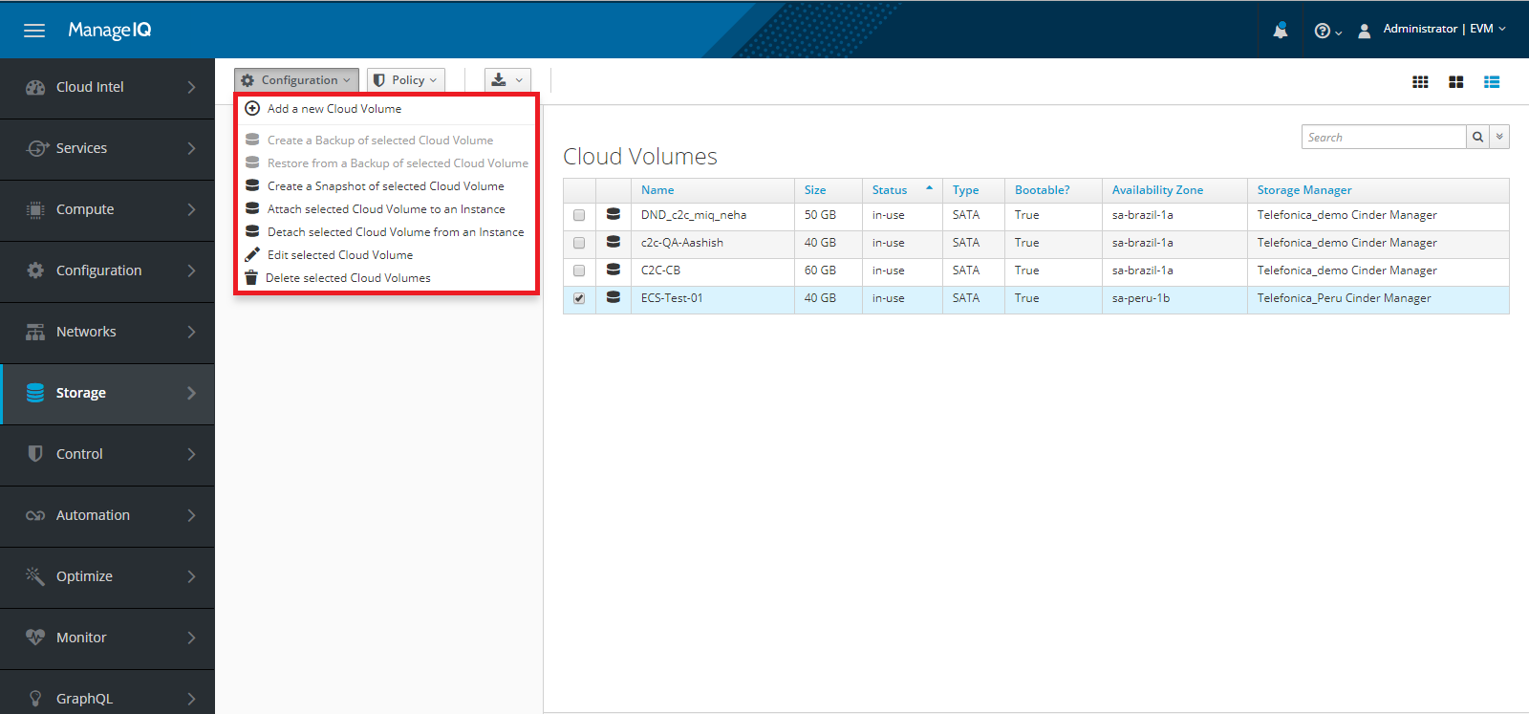

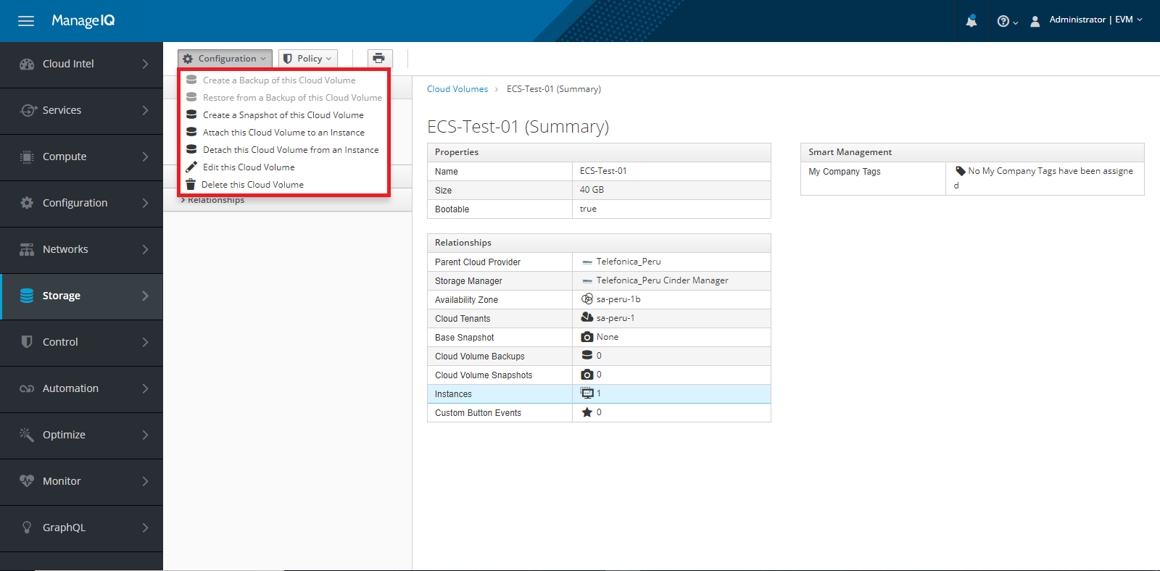

### Add Cloud Volume

Go to **Storage ->Block Storage ->Volumes ->Add a new cloud volume**, here you can add cloud volumes.

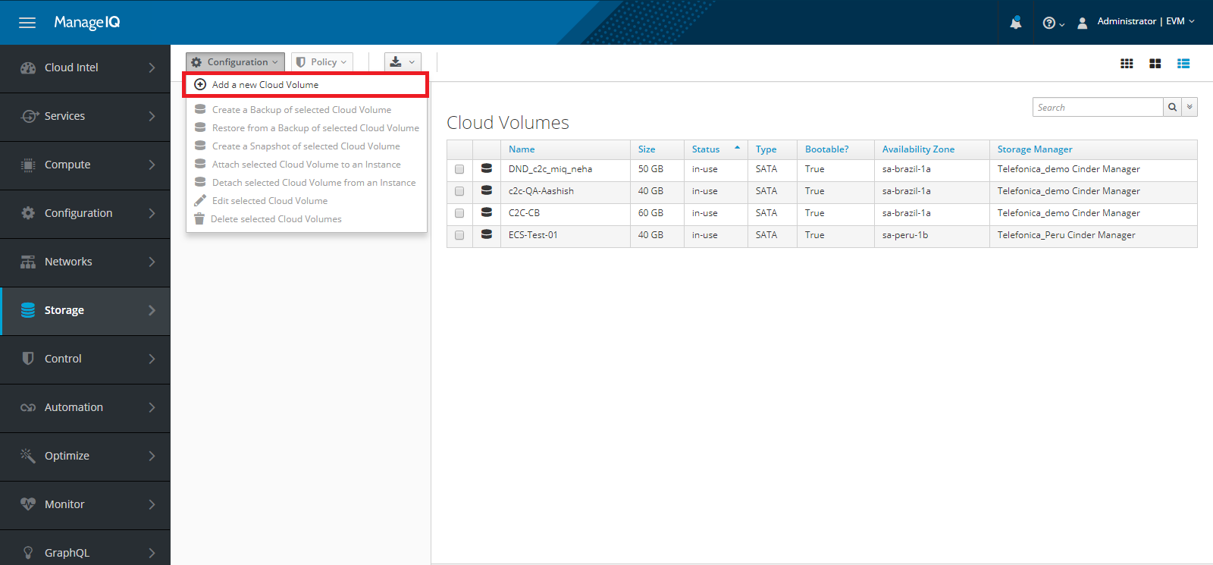

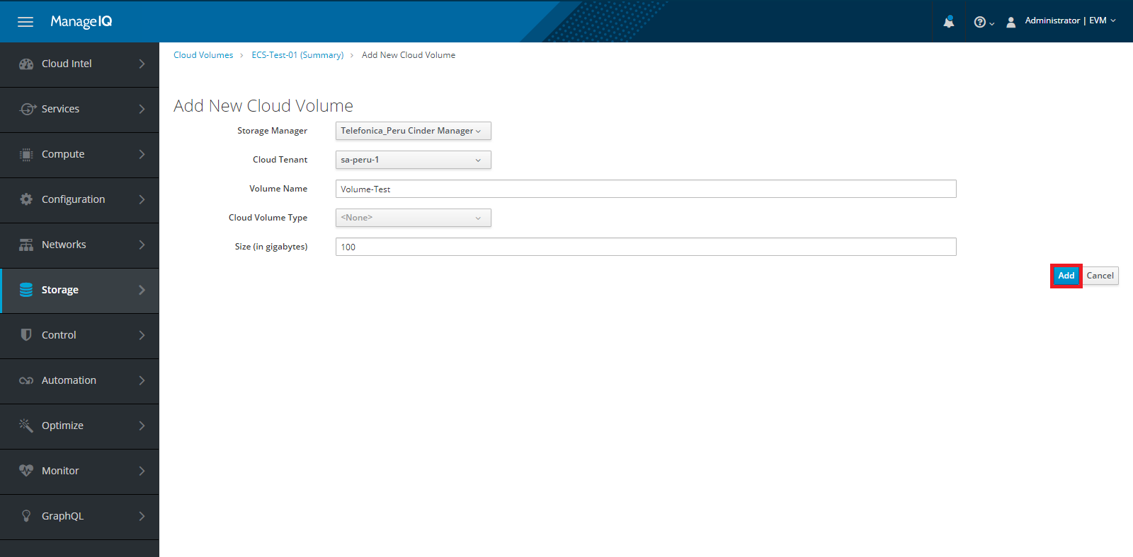

### Volume Snapshot

Go to **Storage ->Block Storage ->Volume Snapshot,** here you can see the list of snapshots, get the detailed information of snapshots and delete cloud volume snapshots.

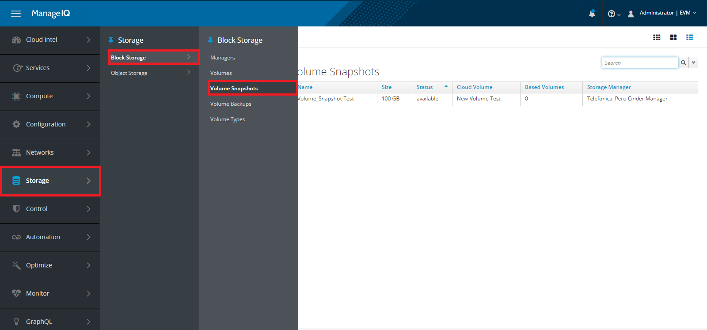

### Create Volume Snapshot

Go to **Storage ->Block Storage ->Volumes.** Here you can create volume snapshot, select a volume and go to **Configuration** and select option **Create a Snapshot to this Cloud Volume**, as shown in below image.

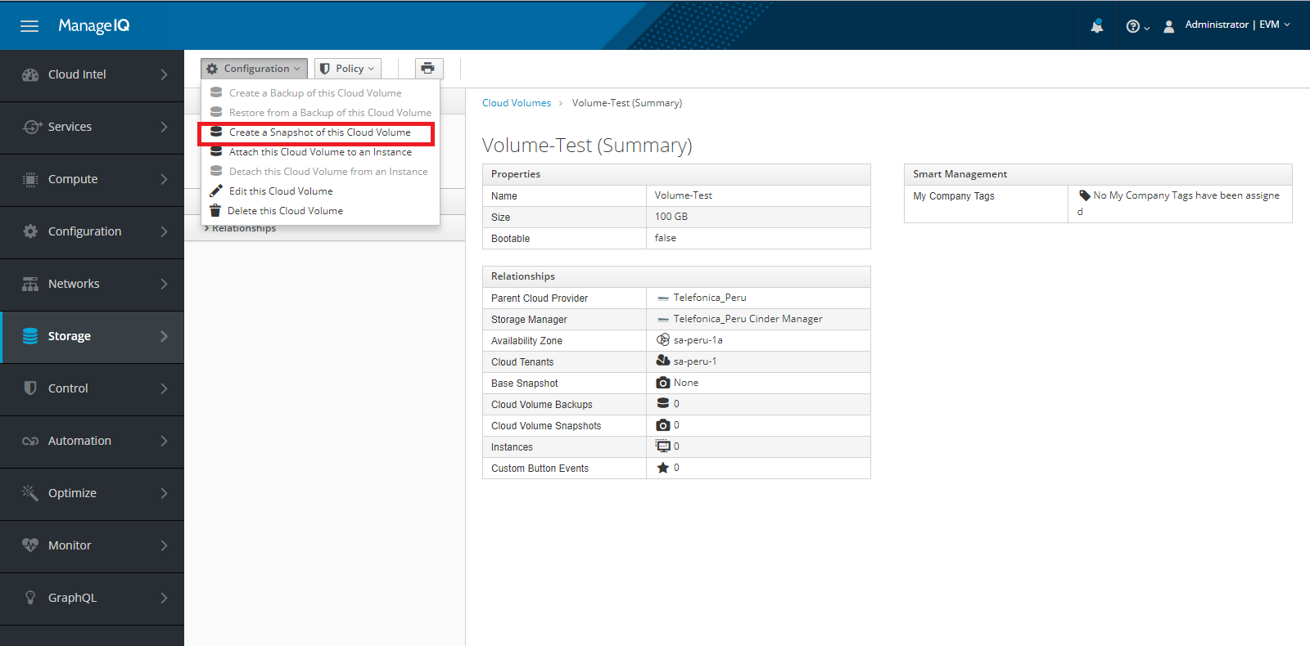

After that give a Snapshot name and click on **Save** button, Snapshot will be created successfully.

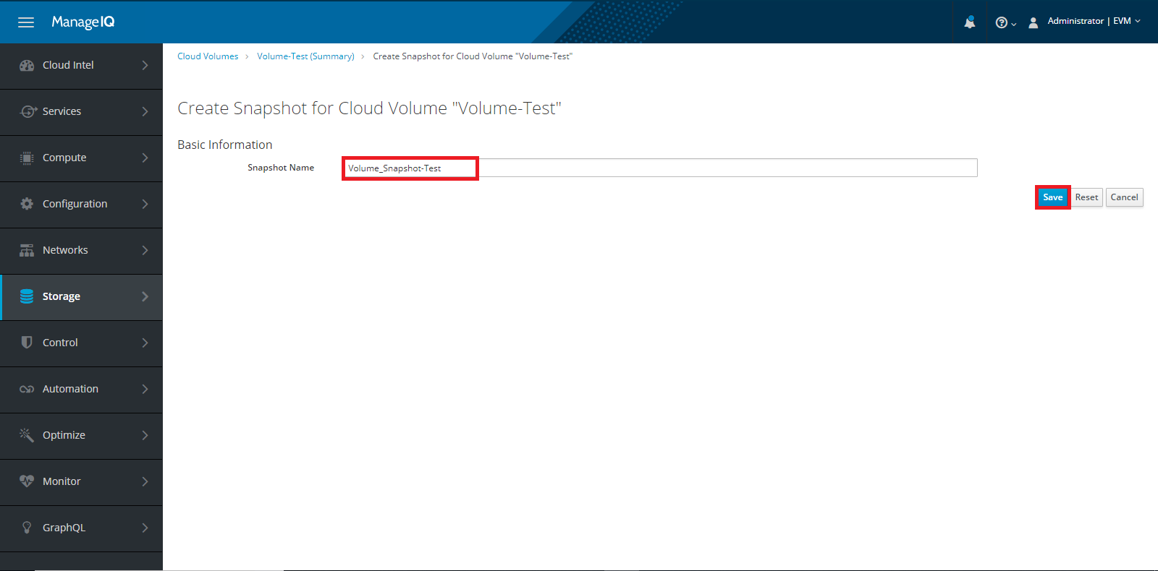

### Delete Snapshot

Go to **Storage ->Block Storage ->Volume Snapshot,** here you can delete cloud volume snapshots.

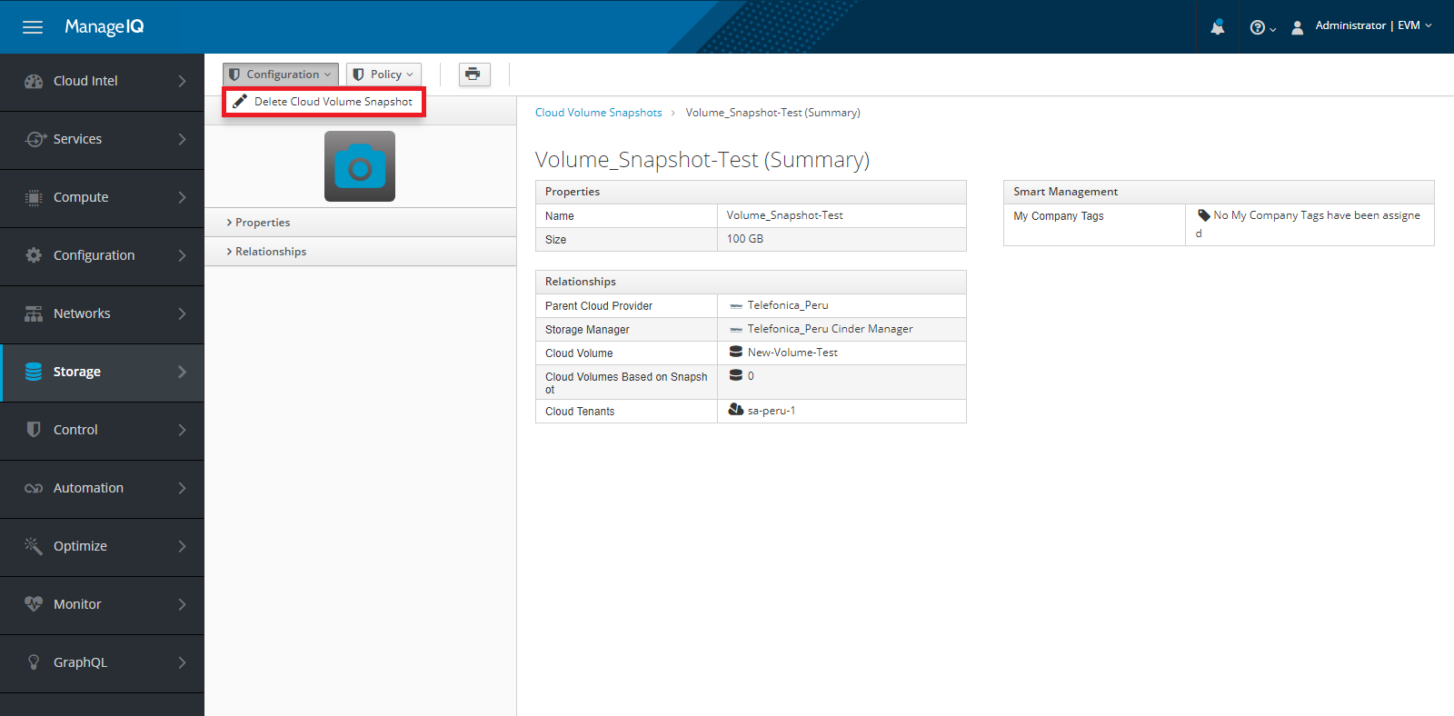

### Attach Volume to VM

Go to **Storage ->Block Storage ->Volumes ->** Here you can attach volume to any instance, select a volume and go to **Configuration** and select option **Attach this cloud Volume to an Instance** as shown in below image.

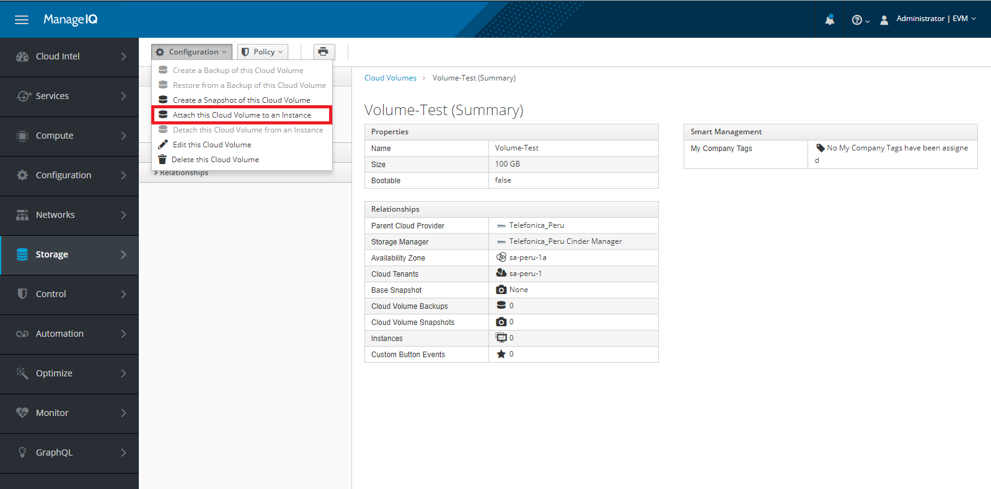

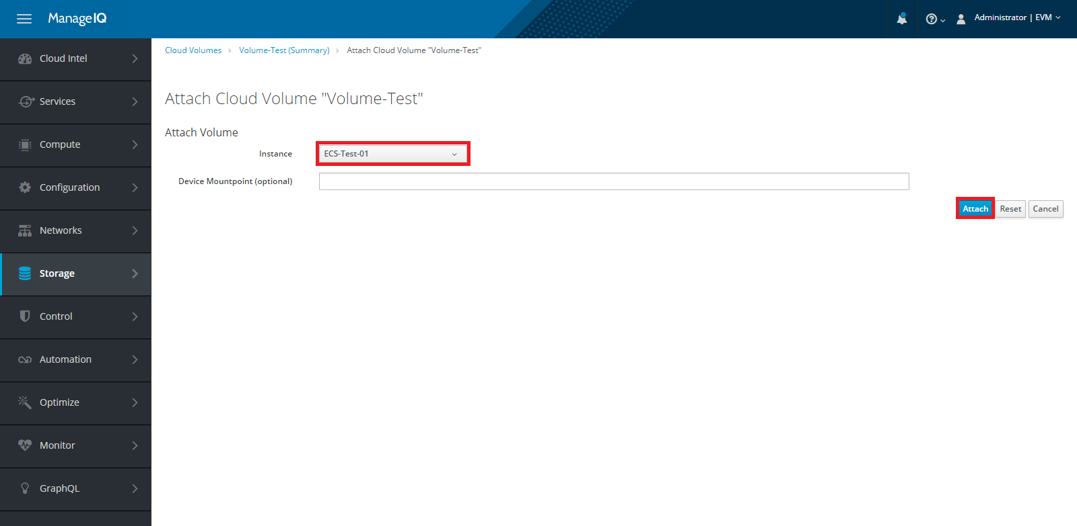

### Detach Volume from VM

Go to **Storage ->Block Storage ->Volumes.** Here you can Detach volume from an instance, select a volume and go to **Configuration** and select option **Detach Selected Cloud Volume from an Instance** as shown in below image.

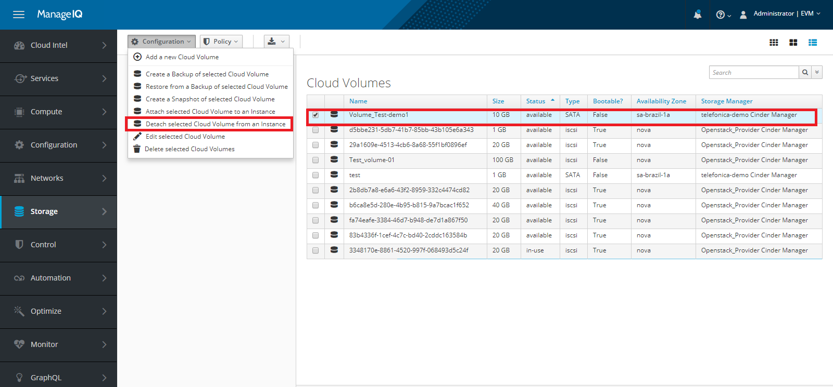

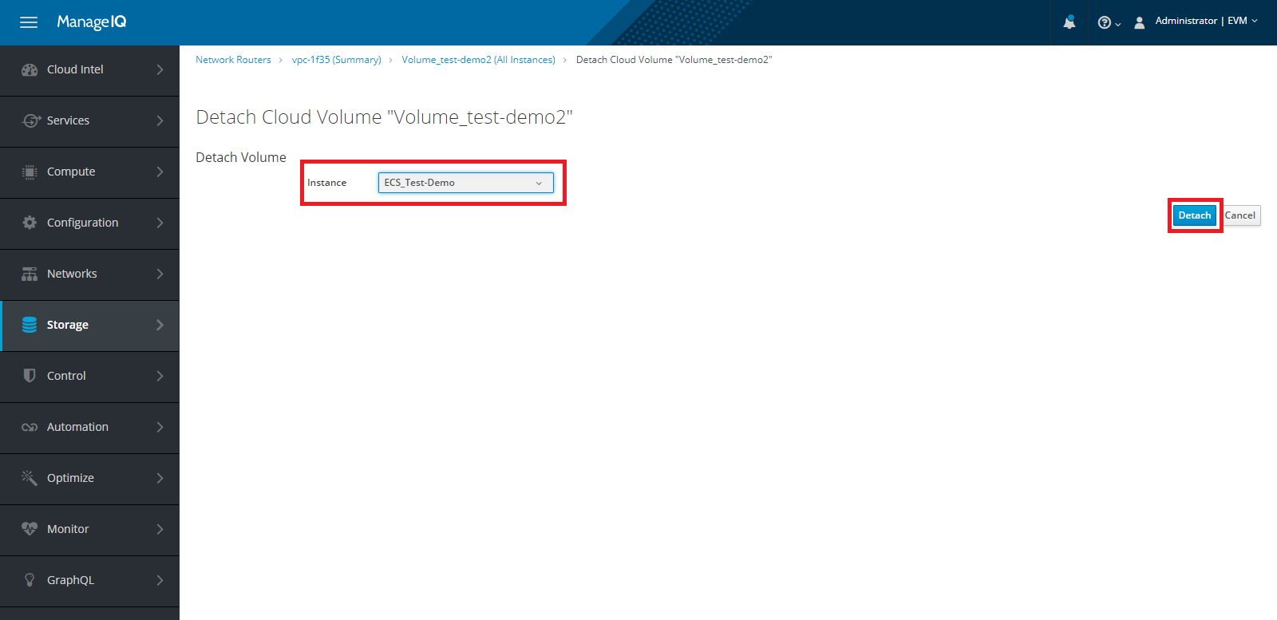

### Edit Cloud Volume

Go to **Storage ->Block Storage ->Volumes.** Here you can edit cloud volume, select a volume and go to **Configuration** and select option **Edit this Cloud Volume**, as shown in below image.

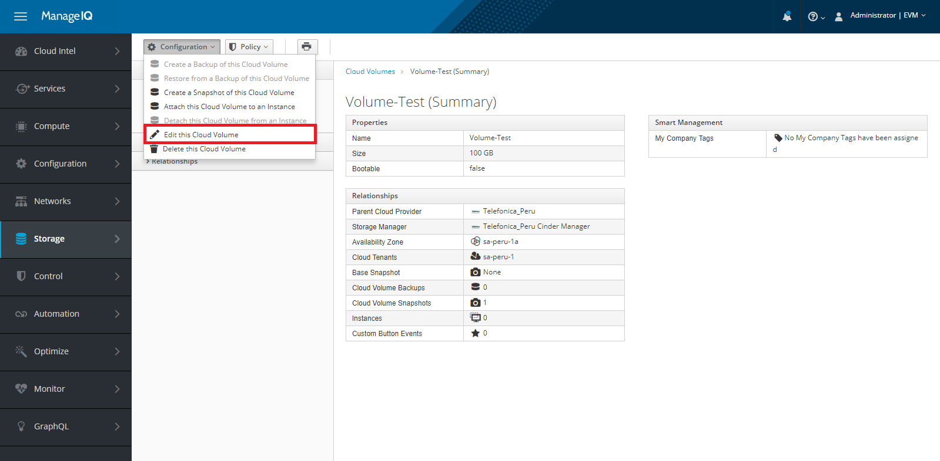

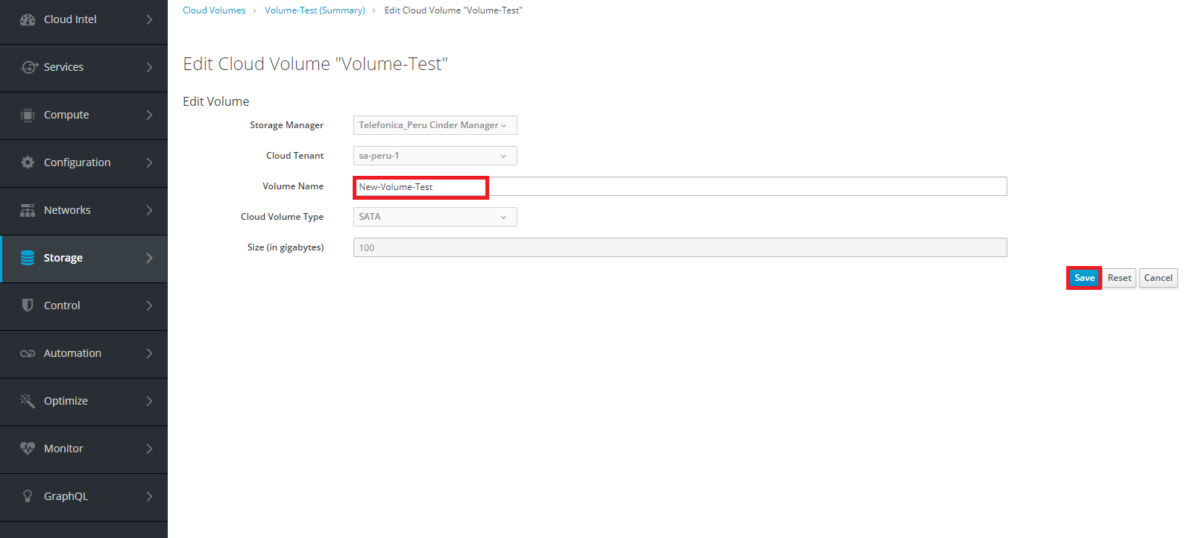

### Delete Volume

Go to **Storage ->Block Storage ->Volumes.** Here you can Delete Cloud Volume, select a volume and go to **Configuration** and select option **Delete Selected Cloud Volumes**, as shown in below image.

